Contents

Week 1 Probability and Random Variables 5

Revision 5

Probability distribution over a random variable 6

Probability distributions over multiple variables 6

Independent random variables 7

Probability mass functions (PMF) 8

Probability density functions (PDF) 9

The cumulative distribution function（CDF） 11

The quantile function 12

The mode of a distribution 12

Week 2 Expectations and Probability Distributions 13

The expected value 14

Variance 14

standard deviation 15

Covariance and Correlation 15

协方差（Covariance） 15

相关系数（Correlation） 16

Approximate Expectations of Functions of RVs 16

Statistical Models as Probability Distributions 17

The Gaussian (normal) distribution 18

Z score 20

Bernoulli Distribution 20

Uniform Distribution 22

Poisson Distribution 23

Week 3 Parameter Estimation and Maximum Likelihood 24

Minimum Sum of Squared Errors (SSE) 24

Maximum Likelihood (ML) 25

ML Estimation of Normal 28

ML Estimation of a Poisson 31

Bias 35

Variance 35

Mean Squared Error (MSE) 35

Consistency 36

Week 4 Central Limit Theorem and Confidence intervals 36

Central Limit Theorem 36

Binomial Distribution 37

Poisson Distribution 38

Confidence intervals 38

Confidence Intervals for the Mean of a Normal Distribution 38

Confidence Intervals for Difference of Normal Means 39

Approximate CIs for sample means 41

Week 5 Hypothesis Testing 42

Testing a normal distribution with known variance 44

Grading p-values and “significance” 46

Summary 46

Testing a normal distribution with unknown variance 47

Testing the difference of means with known variances 49

Testing a Bernoulli Population 50

Tests for a Single Bernoulli Population 51

Testing two Bernoulli populations 52

Can we prove the null hypothesis? 54

Week 6 Linear Regression 54

Supervised Learning 54

Linear Regression 55

The Principle of Least-squares 57

Multiple Linear Regression 58

R^2 values (R squared) 58

Extensions 61

Categorical predictors 61

Nonlinear Effects 61

Selecting Predictors 62

Overfitting and underfitting 63

Information Criteria 64

Finding a good model 64

Week 7 Classification and Logistic Regression 65

Classifiers 65

Direct Construction 65

Learning Simple Classifiers 67

Classifiers as Conditional Probabilities 67

Logistic Regression 67

Linear Predictors 68

Logistic Regression 68

Logistic Regression and Log-Odds 69

Estimating Logistic Regressions 71

Assessing Fit and Selecting Models 71

Predicting with a Logistic Regression 71

Assessing Classifiers 71

Making predictions 71

Classification Accuracy, Sensitivity, Specificity 71

Area-under-the-curve 72

Logarithmic Loss 74

Week 8 Model Selection and Penalized Regression 74

Mean-Squared Prediction Error 74

Variance and Bias with EMSPE 77

Selecting Predictors 79

Hypothesis testing and Multiple Testing Problem 79

Likelihood and Information Criteria 79

Cross-Validation 82

Penalized Regression 84

Conventional Model Selection Methods 84

Statistical Instability 84

Penalized Regression 85

Week 9 Trees and Nearest Neighbour Methods 86

Machine Learning 86

Decision Trees 86

classification vs regression 86

Random Forests 86

Nearest Neighbour Methods 86

k-means algorithm (K MEAN) 86

k means vs knn 87

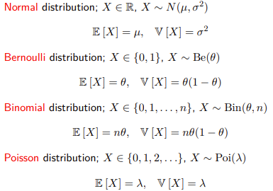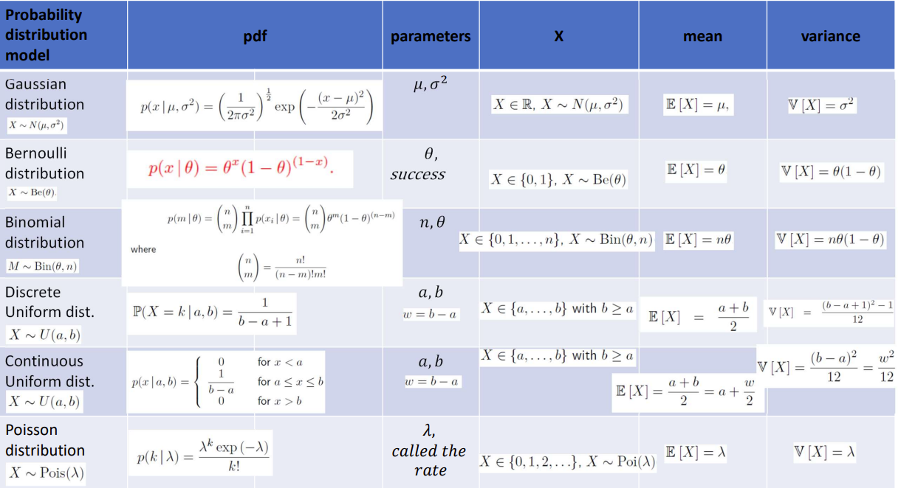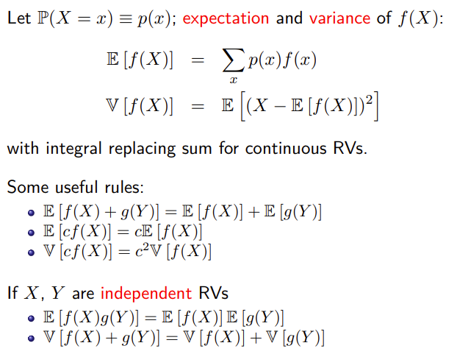

# Week 1 Probability and Random Variables

if A and B have no values in common



where A and B may overlap



## Revision

* X = {a, b, c}, which defines a set X which contains the elements a, b and c
* x ∈ X to denote that the variable x takes on a value from the set X
* A ⊆ X to denote that the set A is subset of X
* A = X ∪ Y set A that contains all of the elements in both X and Y
* A = X ∩ Y, A that contains only those elements that appear in both X and Y
* A = (a, b) denotes the set of numbers from a to b, exclusive, with [a, b] denote an inclusive set.
* Z is the set of all integers
* R is the set of all real numbers
* ∅ denotes the empty set
* Basic Types of Data 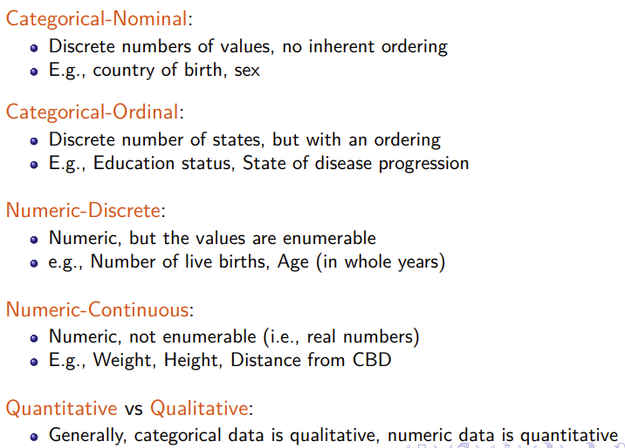

### Probability distribution over a random variable

* We say X is a random variable (RV) if it takes on values from a set of possible values X with specified probabilities
* We sometimes call X the event space, and seeing any x from X as observing the event X = x. We use the notation
* P (X = x), x ∈ X to describe the probability that the RV X will take on the value x from X

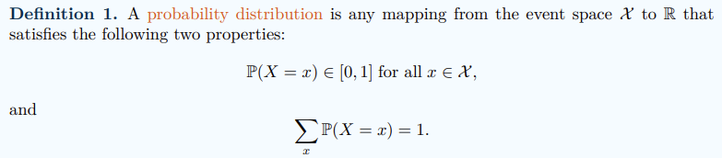

Property

* probability of any event must lie strictly between zero and one
* total probability is 1
* takes a value from a subset A ⊂ X by adding up the probabilities assigned to all events in A 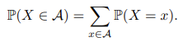
* 
* where A and B may overlap 

## Probability distributions over multiple variables

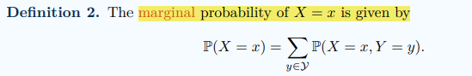

We can then define P(X = x, Y = y), x ∈ X , y ∈ Y as the joint probability of X = x and Y = y. the probability of both X taking on the specific value x and Y taking on the specific value y at the same time. The joint probability distribution completely describes the behaviour of the two random variables

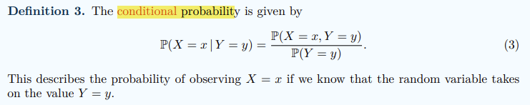

用于描述在给定某些条件下，事件发生的概率。当我们已经知道一些关于事件的信息时，条件概率可以帮助我们估计其他事件发生的可能性

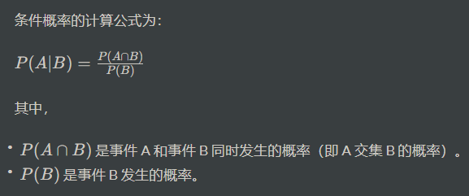

## Independent random variables

统计意义上互不影响的两个或多个随机变量。简单来说，如果两个随机变量之间的变化不受对方的影响，那么它们就是独立的。

* 统计意义上互不影响的两个或多个随机变量。简单来说，如果两个随机变量之间的变化不受对方的影响，那么它们就是独立的。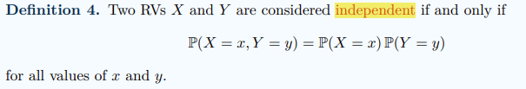
* 条件分布：X 和 Y 之间的条件分布也满足独立性，即对于所有可能的 x 和 y，

有 P(X=x | Y=y) = P(X=x) 和 P(Y=y | X=x) = P(Y=y)

X and Y are independent, the joint probability of X taking on the value x and Y taking on the value y is equal to the product of the marginal probabilities of X = x and Y = y. P(X = x | Y = y) = P(X = x).

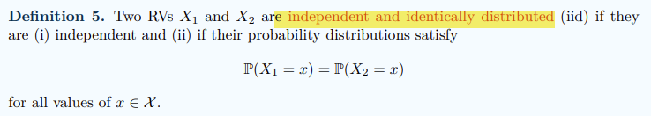

if two RVs are iid, then the two RVs are both independent and possess the same marginal distribution over the event space X.

important because we assume the observations or measurements in our data sample to be independent.

* we do not expect the height of the fourth person we sampled to provide additional information about the height of the fifth person we sampled.

the advantages of this assumption are great simplifications in way in which we construct models of our population from our random data sample.

## Probability mass functions (PMF)

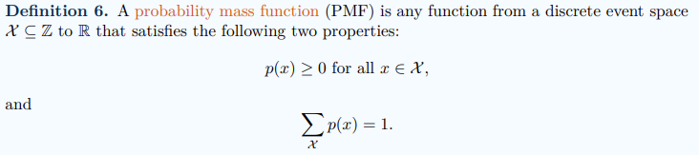

* how much probability is assigned to each event
* advantage that it allows us to specify probabilities over infinite event spaces if a suitable functional form exists, which is clearly not possible by the simple tabulation of events and probabilities that we have seen so far
* 属性
  + 非负性：对于任意的 x，P(X=x) ≥ 0。
  + 概率和为1：所有可能的取值的概率之和等于1，即∑ P(X=x) = 1，其中求和遍历所有可能的取值。
  + 完整性：概率质量函数需要对所有可能的取值都进行定义，即每个可能的取值都有一个对应的概率。
* 

## Probability density functions (PDF)

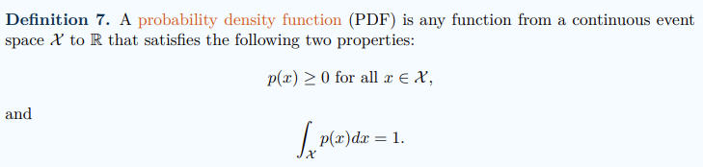 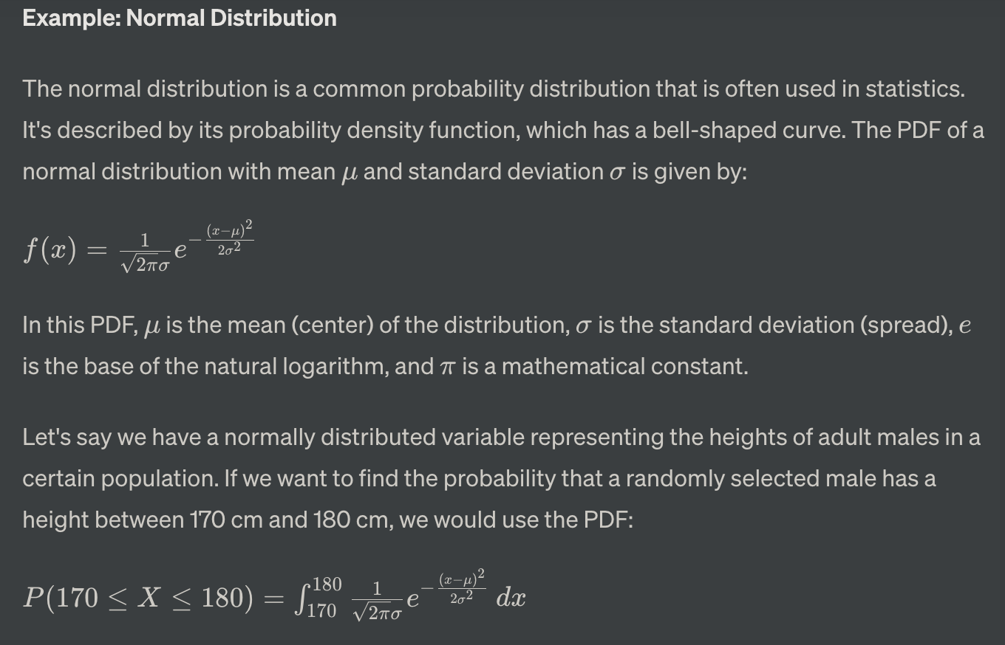b

用于描述连续型随机变量的概率分布情况。PDF描述了随机变量在某个特定取值附近的概率密度，但不直接给出具体的概率值。

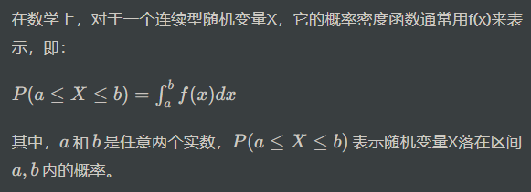

概率密度函数需要满足以下两个条件：



pdf并不直接给出特定点的概率，而是给出在某一范围内的概率密度。要计算特定区间内的概率，需要对概率密度函数在该区间上进行积分。

连续随机变量的任何特定实数值的概率为零：

* 无限多的可能取值：连续随机变量可以在给定范围内取无限多个值。这种无限可能性使得无法为任何特定的个体值分配非零的概率。
* 在区间内定义概率：在连续随机变量的背景下，概率是在区间上定义的，而不是在特定点上。连续随机变量落在特定区间内的概率反映了该区间下PDF曲线下的面积。
* 数学框架：连续随机变量取特定值的概率在数学上被定义为PDF在该单个点上的积分。数学上，PDF在单个点上的积分结果为零，这是由于积分区间的无限小宽度。
* 当处理连续随机变量X时，X恰好等于特定值x0的概率由PDF在该点上的积分表示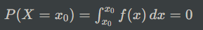
* 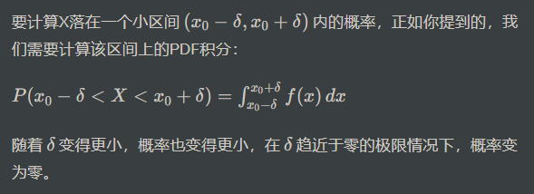

## The cumulative distribution function（CDF）

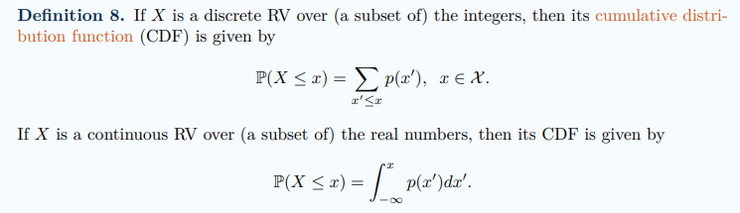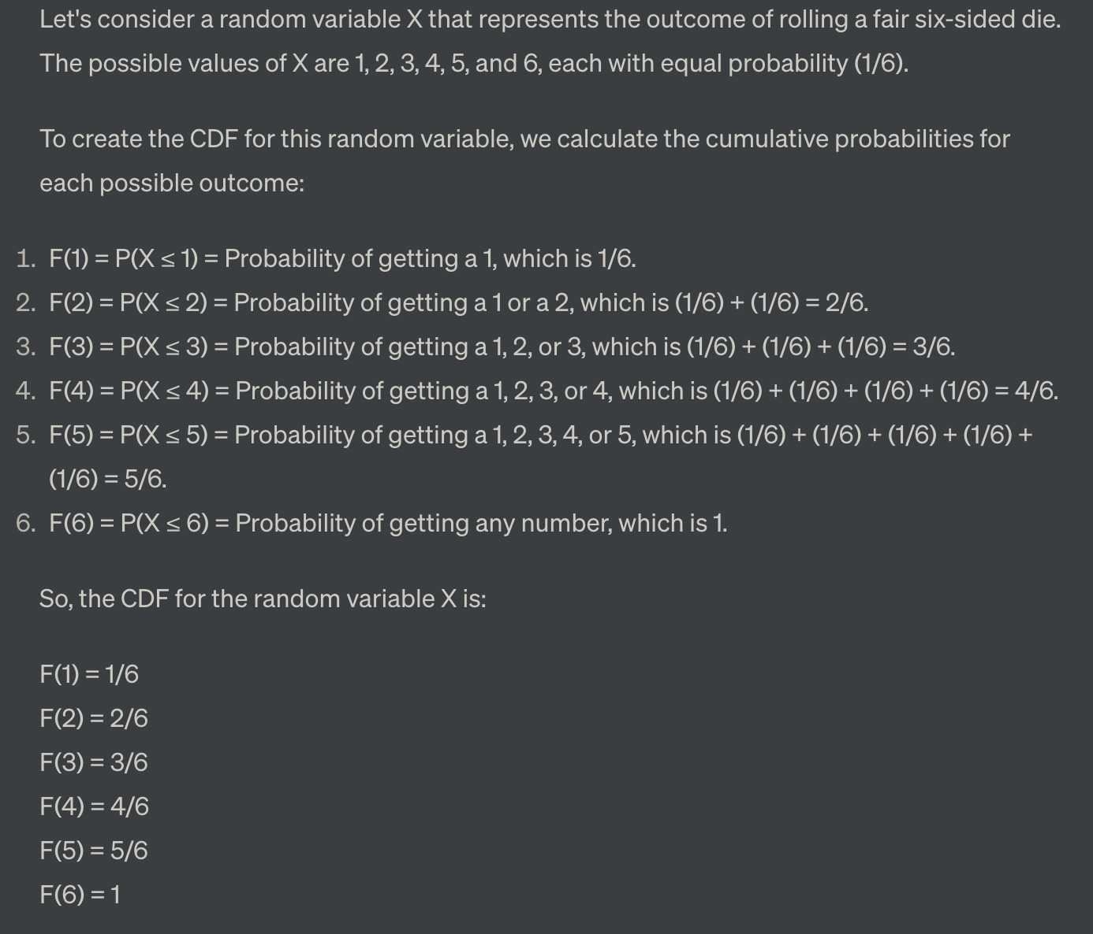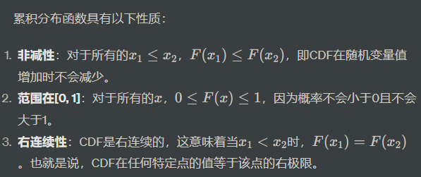

## The quantile function

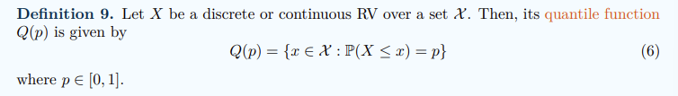

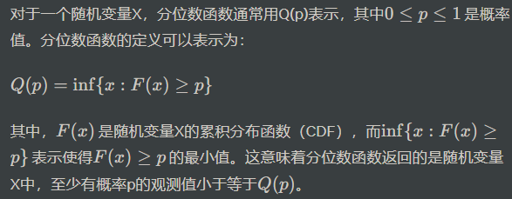

应用包括：



## The mode of a distribution

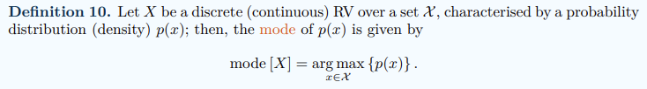

众数的定义：

众数是一个概率分布中概率最大的值。在离散情况下，它是概率分布的某一特定值；在连续情况下，它是使概率密度函数取最大值的点。

离散随机变量的众数：

对于离散随机变量X，众数是概率分布中具有最大概率的值。在离散情况下，众数是一个明确定义的值，它代表着随机变量的最可能值，因此也代表着随机变量的“典型”值。

连续随机变量的众数：

对于连续随机变量X，众数是使概率密度函数取最大值的点。然而，在连续情况下，特定单个实数值的概率确实等于零。因此，连续分布的众数的解释较离散情况下略显复杂。尽管如此，众数仍然代表着分布的典型值或平均值，因为它对应于概率密度最大的值。由于大多数概率密度函数都是连续的，人们可以期望在众数附近的小邻域内，概率密度较高。

# Week 2 Expectations and Probability Distributions

IMPORTANT:  
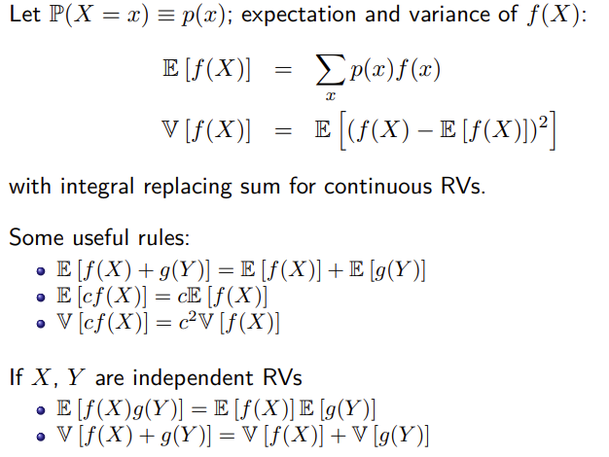

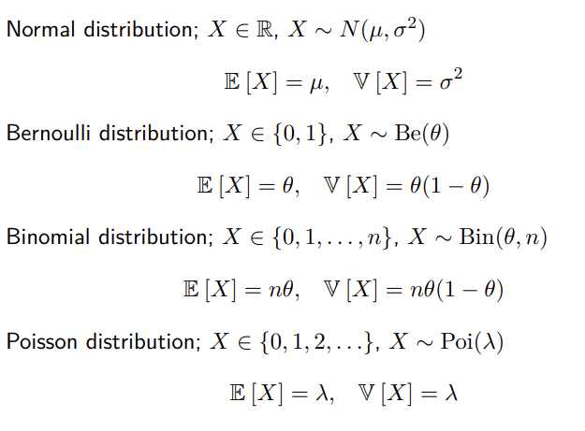

## The expected value

期望值（Expected Value），又称为平均预期值、期望平均数或期望，它表示在一系列可能结果中，每个结果乘以其发生的概率后的总和，即对所有可能结果的概率加权平均值，它是对随机事件结果的平均预期，可以帮助我们理解随机变量的中心趋势。

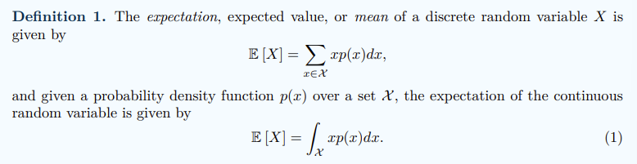

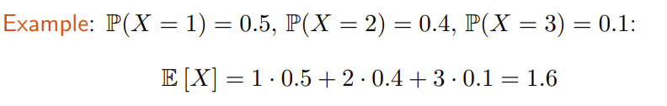

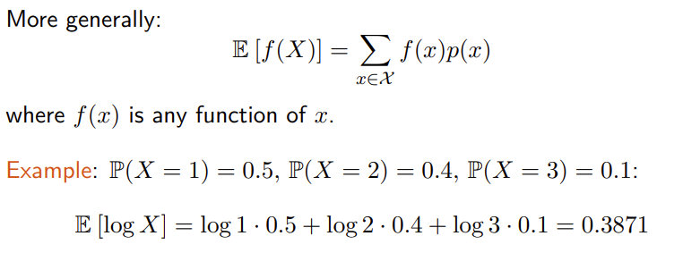

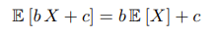 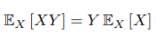 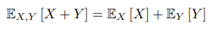 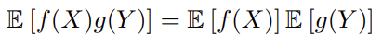

## Variance

用来衡量一组数据的离散程度或波动程度。它是数据点与数据集均值之间差异的平均平方，用来度量数据的分散程度

* 方差越大，数据点相对于均值的离散程度越高，说明数据集中的数据分布较分散

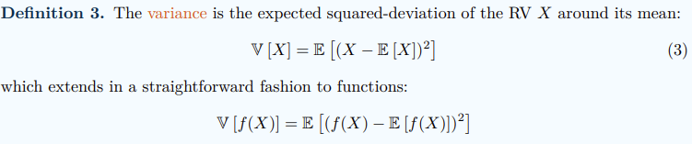

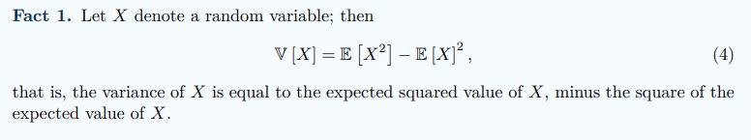

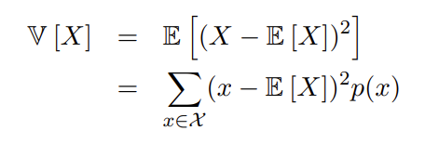 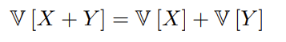 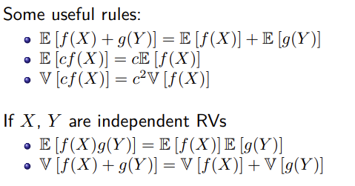

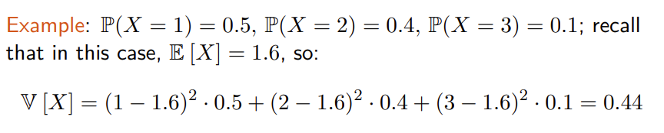

### standard deviation

The standard deviation measures the average square-rooted squared deviation of a random variable X around its mean E [X]. An important property of the standard deviation, in comparison to the variance, is that it has the same units of measurement as the RV X; that is, if X is measured in meters, then so is its standard deviation

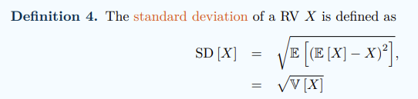

## Covariance and Correlation

### 协方差（Covariance）

协方差衡量了两个随机变量在同一时间内如何变化，即它们的变化趋势是否相似。具体来说，如果两个变量的值同时增加或减少，那么它们的协方差为正；如果一个变量增加而另一个变量减少，协方差为负。协方差的计算公式为：

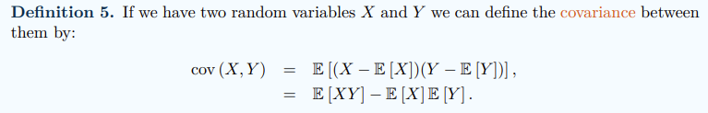

Covariance between (−∞, ∞)

### 相关系数（Correlation）

相关系数衡量了两个变量之间的线性关系强度和方向。最常用的是皮尔逊相关系数（Pearson correlation coefficient），它的取值范围在 -1 到 1 之间。具体来说，相关系数为正表示两个变量之间存在正相关关系（一个增加，另一个也增加），相关系数为负表示两个变量之间存在负相关关系（一个增加，另一个减少），相关系数接近于 0 表示两个变量之间关系较弱。皮尔逊相关系数的计算公式为：

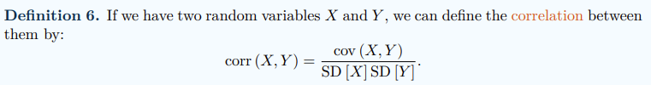

Correlation between [−1, 1]

If X, Y independent, cov (X, Y ) = corr (X, Y ) = 0: Converse is not true

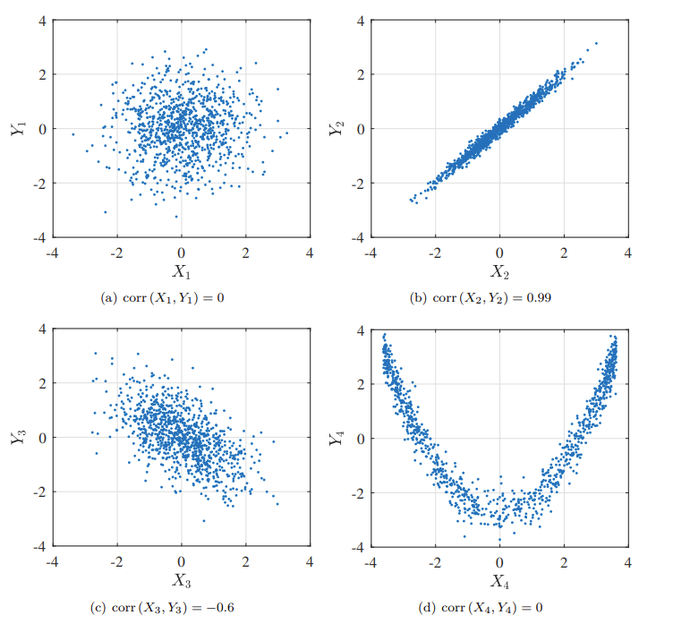

### Approximate Expectations of Functions of RVs

In many real-world scenarios, it might be challenging or even impossible to compute exact expectations due to complex functions or limited information about the underlying probability distributions.

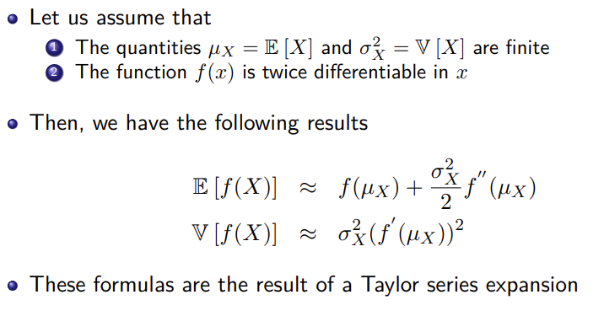

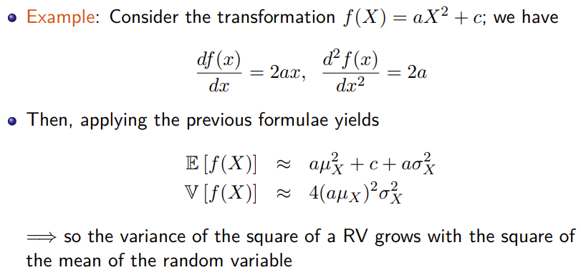

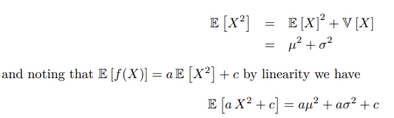

## Statistical Models as Probability Distributions

We specify the probability density function by p(x | θ), x ∈ X , θ ∈ Θ

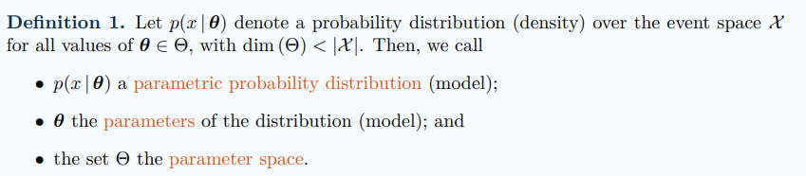

### The Gaussian (normal) distribution

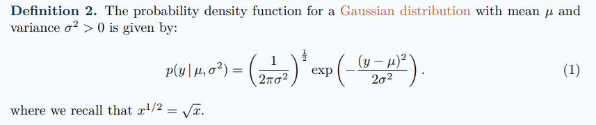

µ is the mean of the distribution; σ^2 is the variance of the distribution

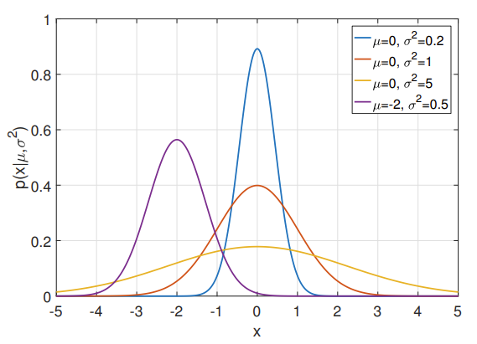

If X follows a Gaussian distribution, we write that

* X ∼ N(µ, σ^2 )
* E [X] = µ = mode = median
* V [X] = σ^2

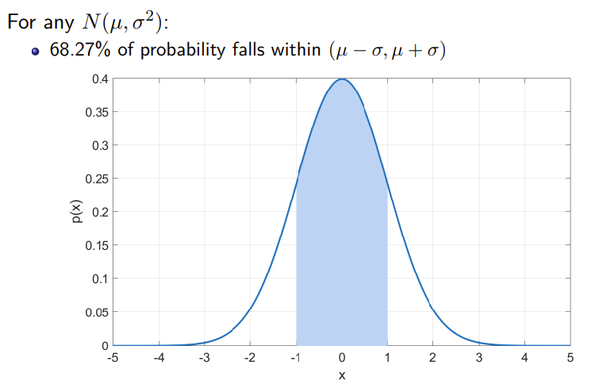

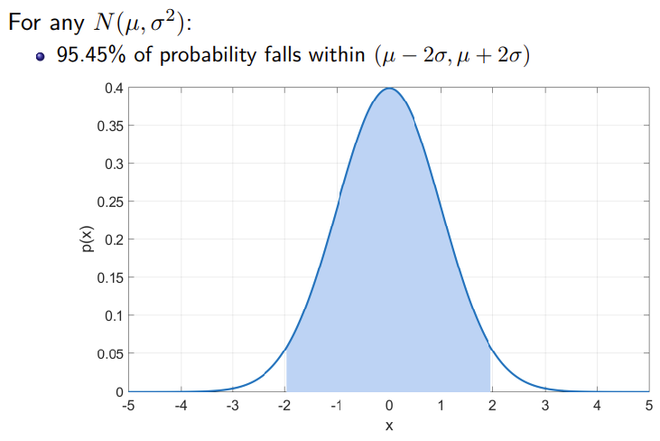

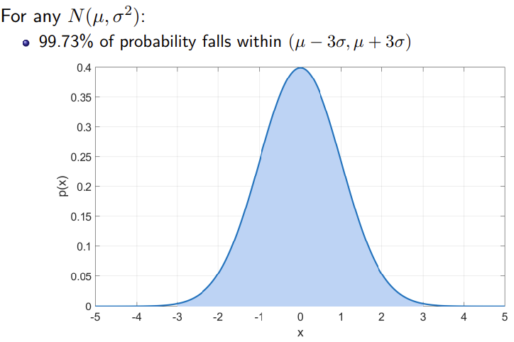

Property:

* self-similarity
  + Every Gaussian distribution is a translated and scaled version of the standard normal distribution N(0, 1)
* Additivity
  + 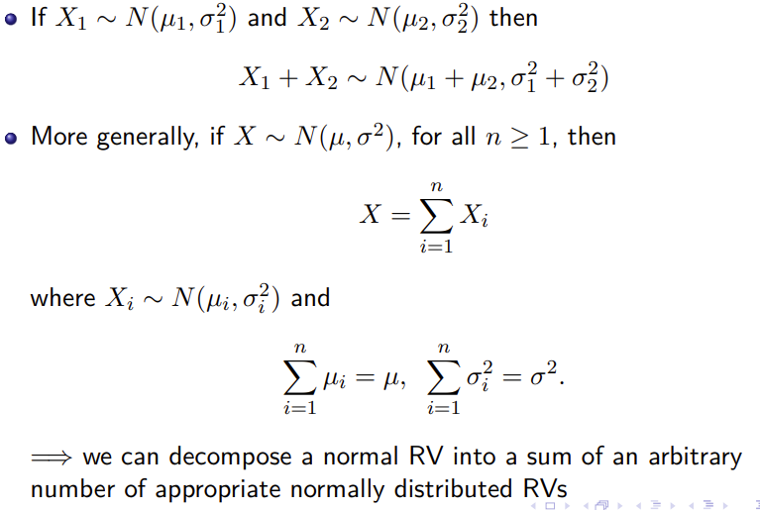

### Z score

A Z-score, also known as a standard score, measures how far a particular data point is from the mean of a dataset, expressed in terms of standard deviations. It's a way to standardize and compare data points from different distributions.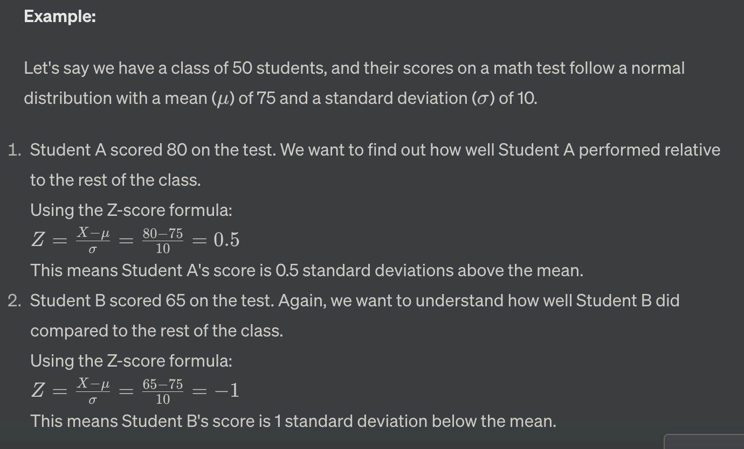

### Bernoulli Distribution

Now consider n binary RVs X = (X1, . . . , Xn). x = (0, 1, 1, 1, 0, 1, 0, 0, 1, 1)

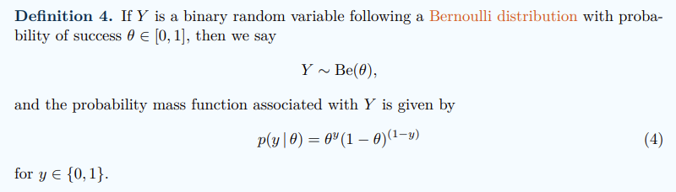

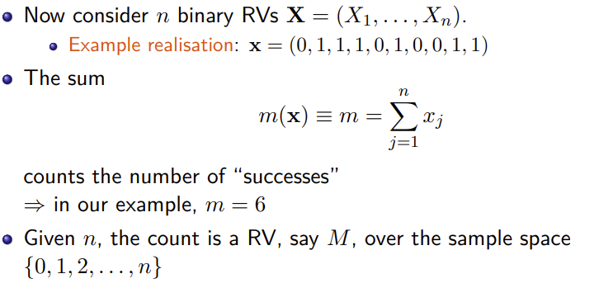 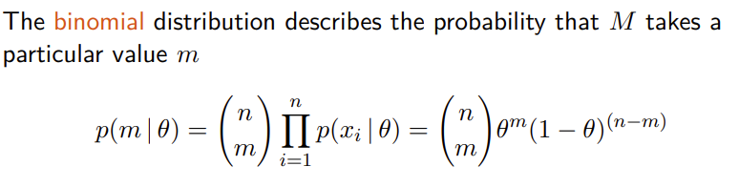

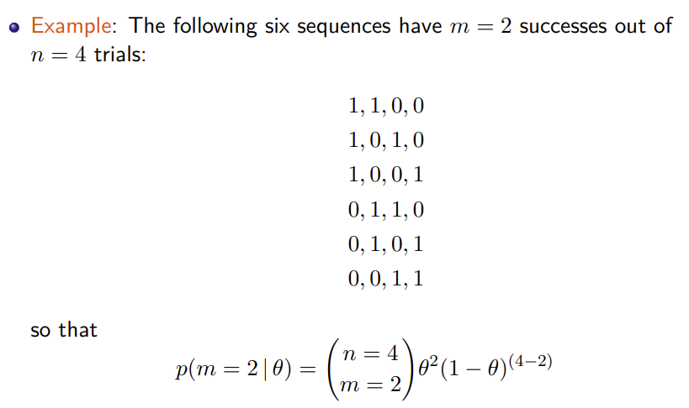

### Uniform Distribution

#### Discrete Uniform Distribution

离散均匀分布通常用于描述一个随机变量取值在一定范围内且各个取值之间的概率相等的情况。比如，投掷一个公正的六面骰子，每个面出现的概率都是1/6. 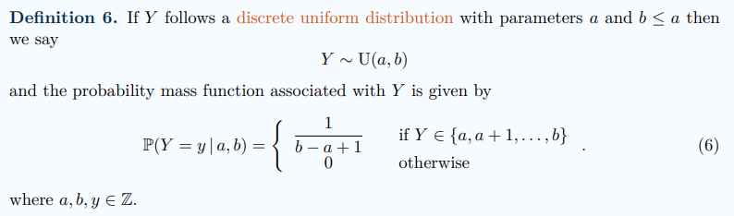

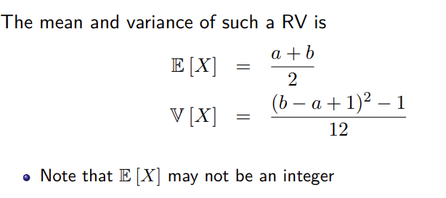

#### Continuous Uniform Distribution

例如，假设我们有一个从0到1的连续均匀分布，那么在这个区间内任意一个小区间上的概率都是相等的。

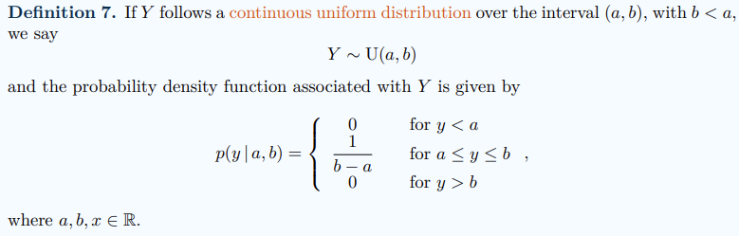 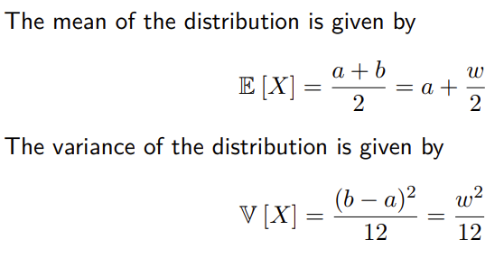

### Poisson Distribution

泊松分布（Poisson Distribution）是描述在一个固定时间段或空间区间内，某个事件发生次数的概率分布模型。它通常用于描述在一个连续时间或空间区间内，独立且稀有事件（发生概率很低）发生的次数。

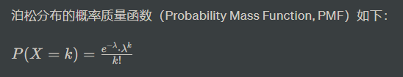

其中，

X 是事件发生的次数，

k 是一个非负整数，

λ 是一个正实数，表示在给定的时间段或空间区间内，事件的平均发生次数

example:

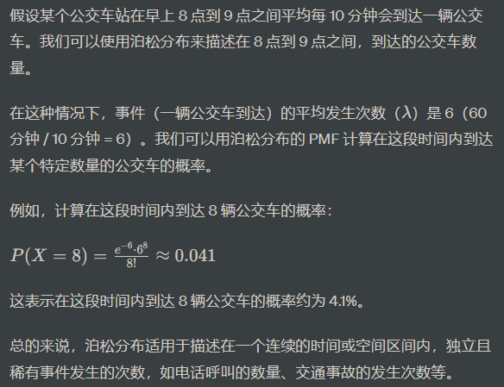 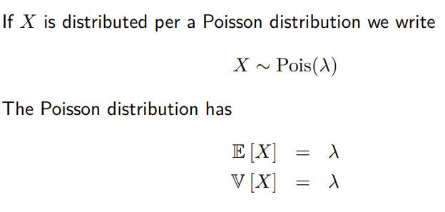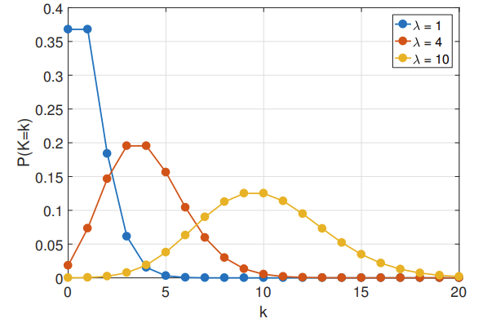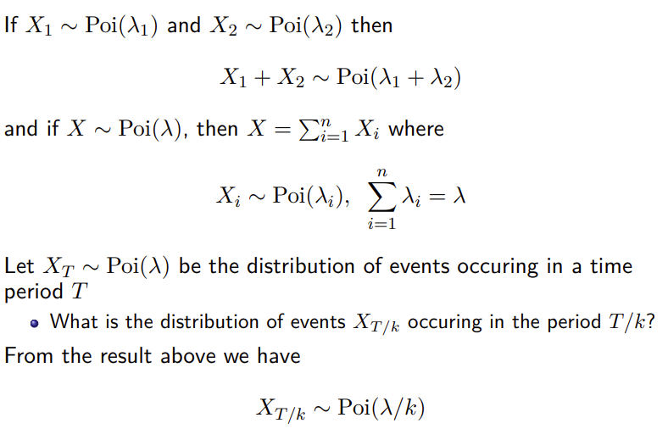

# Week 3 Parameter Estimation and Maximum Likelihood

## Minimum Sum of Squared Errors (SSE)

Minimum Sum of Squared Errors (SSE) 是一个用于衡量回归模型拟合程度的指标。它是一种常用的评估回归模型性能的方法。

在回归分析中，我们试图建立一个模型来预测一个（dependent variable）Y，其取值受到一个或多个（independent variables）X的影响。模型的目标是找到一条线（或曲线），使得预测值与实际观测值之间的误差尽可能地小。通过最小化 SSE，我们可以找到最优的拟合线（或曲线），使得模型对数据的拟合效果最好。

* SSE 越小越好
* SSE 等于零的理想情况：如果模型完全拟合数据，预测值与实际值完全一致， SSE 将等于零
* SE 的值没有单位

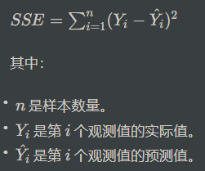 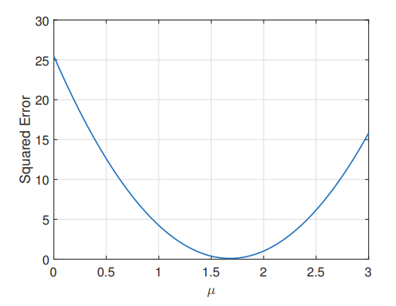

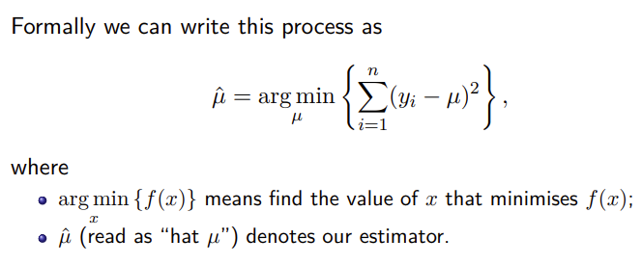

Estimators are usually identified by putting a hat on the quantity we are estimating

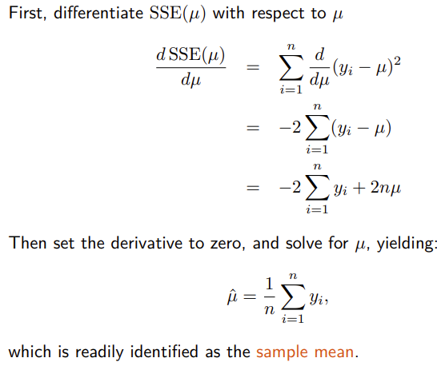

## Maximum Likelihood (ML)

是一种用于估计统计模型参数的方法。它的基本思想是，我们希望通过调整模型的参数，使得在给定观测数据的条件下，所得到的样本出现的概率最大化。

here we use θ to refer to generic parameters of a distribution. The larger the probability, the more likely the observed data would be to arise under that model.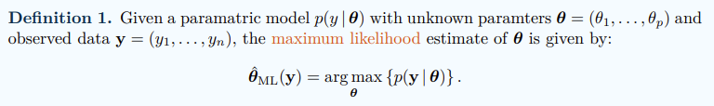 

where L(y | θ) = − log p(y | θ) is called the negative log-likelihood

L(θ|X)，其中θ表示待估计的参数，X表示观测到的数据。MLE的目标是找到最大化似然函数L(θ|X)的θ值。

在这个例子中，0.6 是最大似然估计得到的结果，它表示硬币正面朝上的概率的估计值。

具体来说，0.6 意味着根据观测到的投掷结果，我们估计硬币正面朝上的概率为 60%。这并不是一个确定的值，而是在当前的实验条件下，最大似然估计得到的一个可能的参数值。

### ML Estimation of Normal

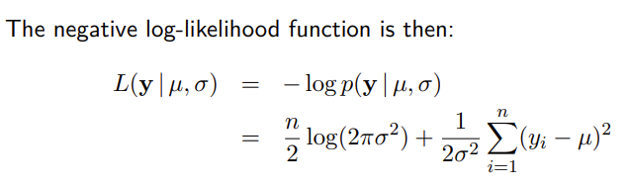 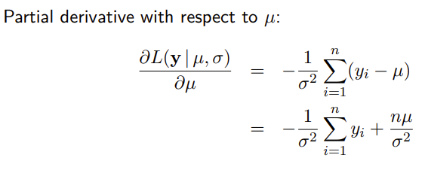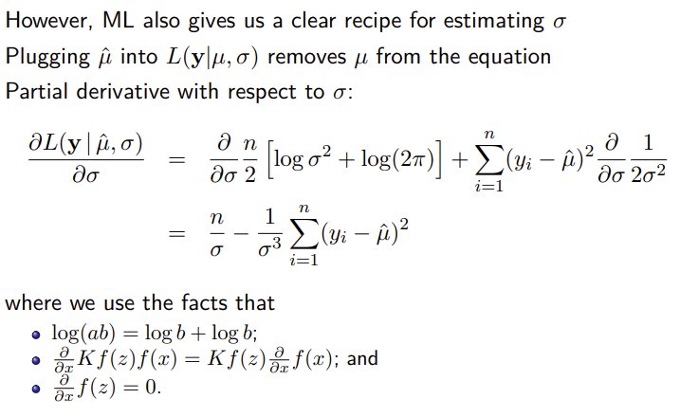 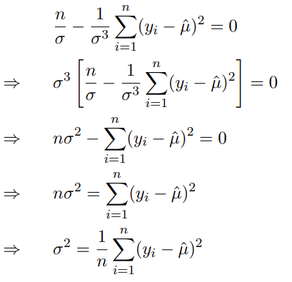 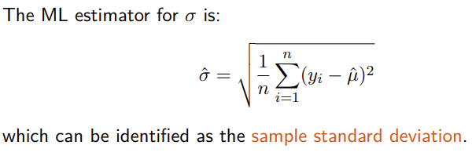

Example:

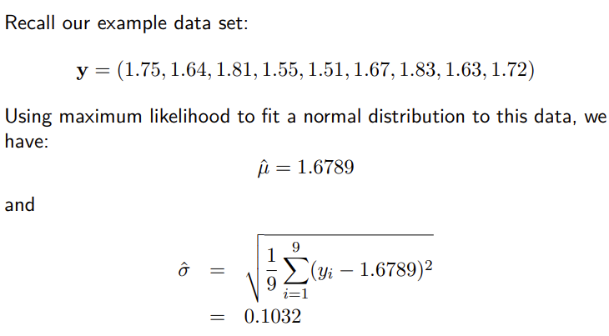 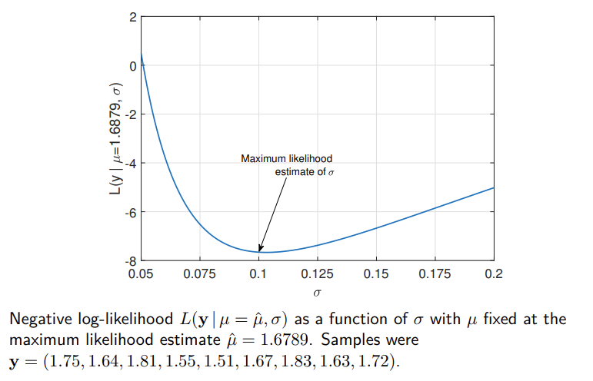 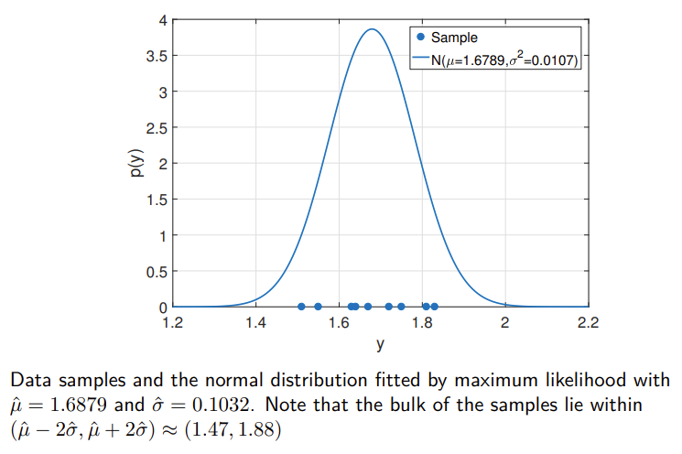

#### Probability Density Function，PDF

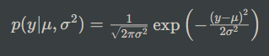

#### Likelihood function

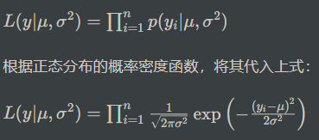

#### Log-Likelihood function

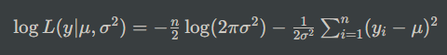



### ML Estimation of a Poisson

y表示非负整数，λ 是泊松分布的一个参数，代表单位时间（或单位空间等）内事件发生的平均次数

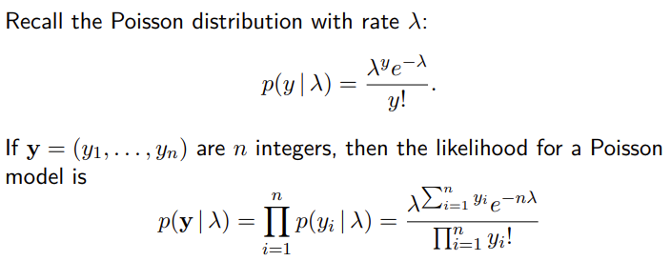

#### Log-Likelihood function

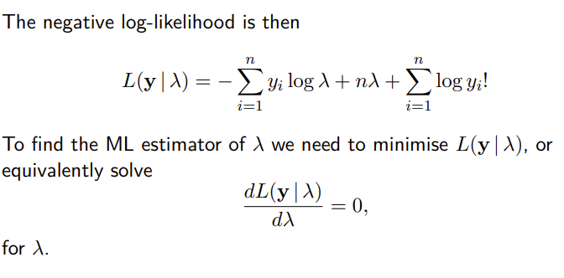

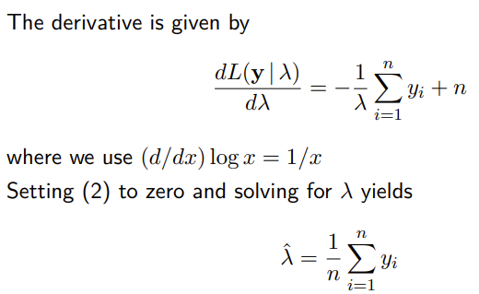

Example:

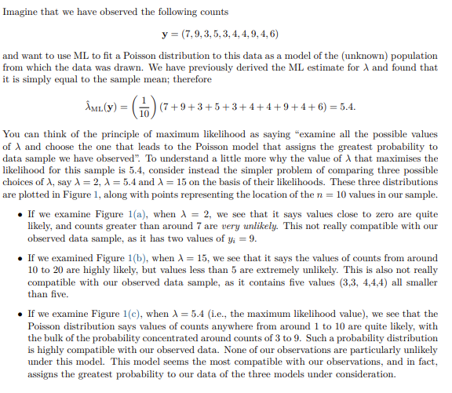 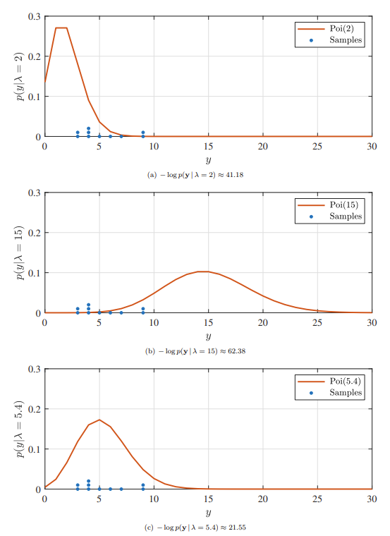

### Bias

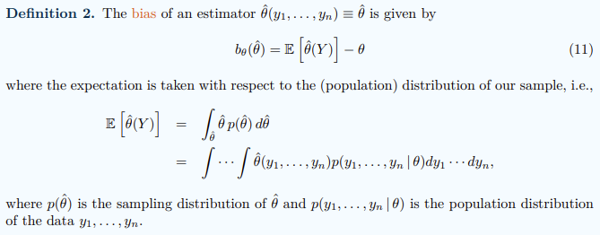



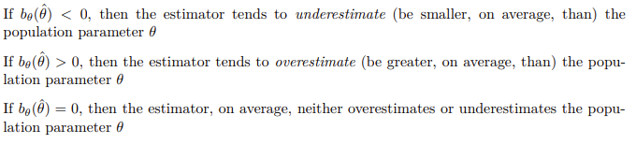

### Variance

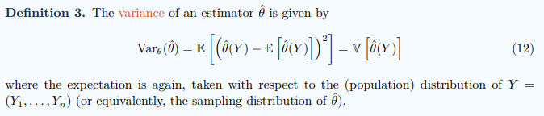

### Mean Squared Error (MSE)

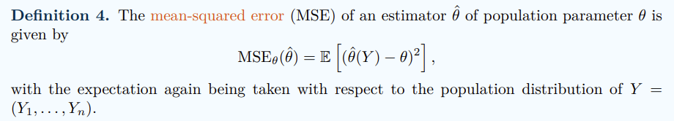

是一个用于衡量模型预测与实际观测值之间差异的指标。它的计算方法是将每个观测值的预测误差平方后求平均。因此，MSE越小，表示模型的预测与实际值之间的差异越小，模型的性能越好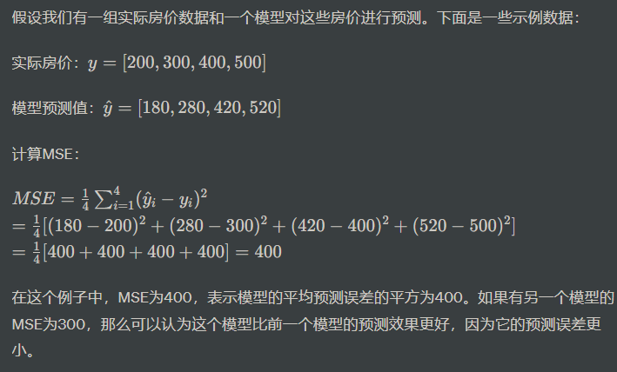

### Consistency

特指当样本的数量趋向无穷大时，估计量将会接近真实参数值的性质。假设我们想要估计某种药物的平均疗效，我们进行了一系列的实验，每次实验使用不同的样本量来评估疗效。我们使用样本平均值作为估计量。

如果我们发现随着实验次数的增加，估计的平均疗效逐渐稳定在一个特定的值附近，那么我们可以说我们的估计量是一致的。这意味着无论我们使用多少样本，我们的估计值都会越来越接近真实的平均疗效。

如果估计值在不同的实验中波动很大，那么我们的估计量可能不是一致的，这意味着我们的估计可能不够稳定或准确。

# Week 4 Central Limit Theorem and Confidence intervals

## Central Limit Theorem

The Central Limit Theorem (CLT) is a fundamental concept in statistics. It states that the distribution of the sample mean of a large enough sample from any population will be approximately normally distributed, regardless of the shape of the original population distribution.

Example:

Let's say we have a population of students and we're interested in their scores on a difficult math exam. The scores in the population have a distribution that is not necessarily normal. Some students score very high, some very low, and most fall somewhere in between.

We randomly sample 100 students from this population and calculate their average score. Then, we repeat this process many times, each time taking a different random sample of 100 students and calculating their average score.

According to the Central Limit Theorem, if we were to plot the distribution of these sample means, it would approximate a normal distribution, regardless of the shape of the original population distribution.

Explanation:

Sampling: By taking multiple samples and calculating their means, we are essentially simulating the process of conducting numerous experiments.

Sample Mean Distribution: As we collect more and more sample means, we can plot them on a graph. According to the Central Limit Theorem, this distribution of sample means will approach a normal distribution.

Approximation of Normal Distribution: The larger our sample size, the closer the distribution of sample means will be to a perfect normal distribution. Even with relatively small sample sizes (around 30 or more), the approximation can be quite good.

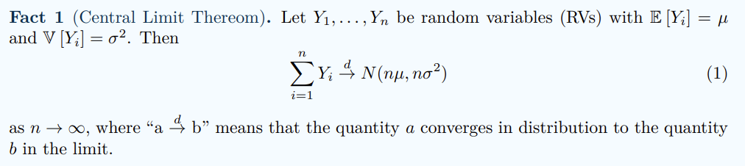

### Binomial Distribution

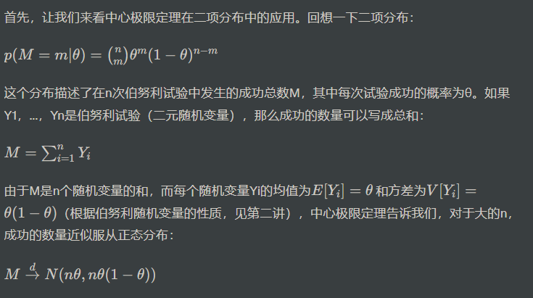

如果你抛掷一枚硬币n次并记录成功的次数，然后重复多次并绘制成功次数的直方图，你会发现对于大的n，该分布近似为正态分布。也就是说，在足够多的抛掷中，零和一的总和产生了一个（基本上）正态分布的随机变量！

### Poisson Distribution

根据泊松分布的性质，我们知道每个随机变量Yi的期望E[Yi] = 1，方差V[Yi] = 1。因此，根据中心极限定理，当λ趋向于无穷大时，S的分布趋近于正态分布N(λ, λ)。简而言之，如果事件发生的速率非常大，那么在一段时间内事件发生的次数分布将近似为正态分布。

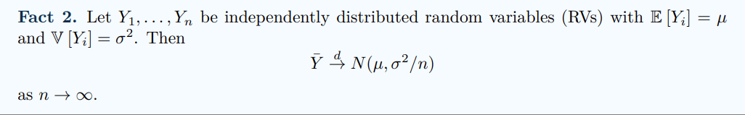

泊松分布的正态性质还导致了另一个有趣的结论，这与泊松分布的可分性（divisibility）有关。可分性意味着如果某一时间段T内事件发生的速率是λT，那么k倍时间段kT内事件发生的速率就是kλT。因此，尽管在短时间段内事件发生的次数可能不是正态分布（如果λ很小），但如果考虑的时间段足够长，它们将近似为正态分布。例如，一小时内出生的婴儿数量可能不是正态分布的，但一年内出生的婴儿总数更有可能近似为正态分布，因为一年内出生的速率是每小时出生速率的365×24倍。有趣的是，这进一步支持了在第1.1节中讨论的自然现象为什么经常呈正态分布的论点。

## Confidence intervals

A confidence interval is a statistical concept that provides a range of values within which a population parameter is likely to fall with a certain level of confidence. It is often used to estimate the range in which a true population parameter (such as a population mean or proportion) is likely to be, based on a sample from that population.

A confidence interval is typically represented as:

Point Estimate±Margin of Error

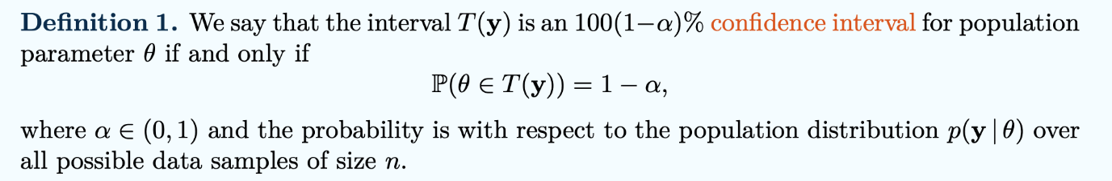

### Confidence Intervals for the Mean of a Normal Distribution

#### CI for Normal Mean with Known Variance

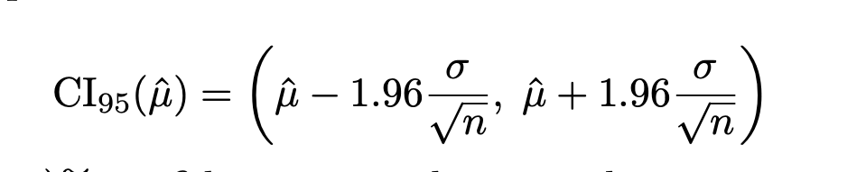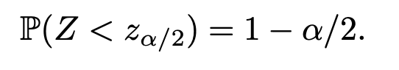

Example:  
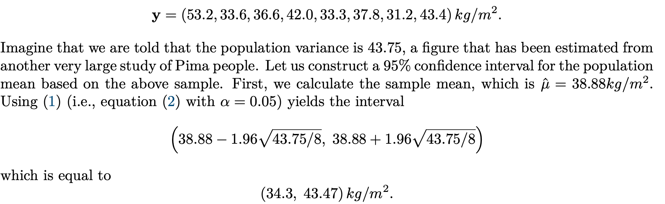

#### CI for Normal Mean with Unknown Variance

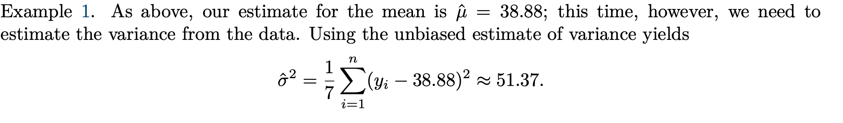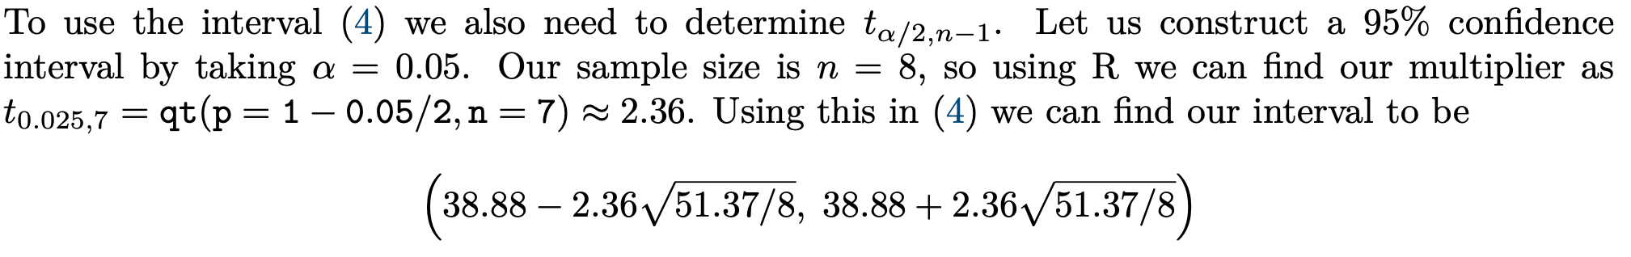

### Confidence Intervals for Difference of Normal Means

#### CI for Difference of Normal Means with known Variances

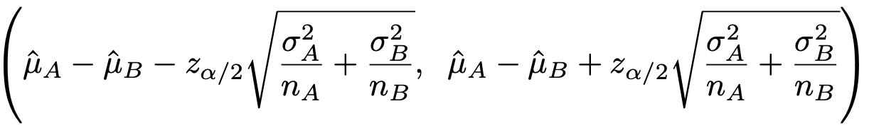

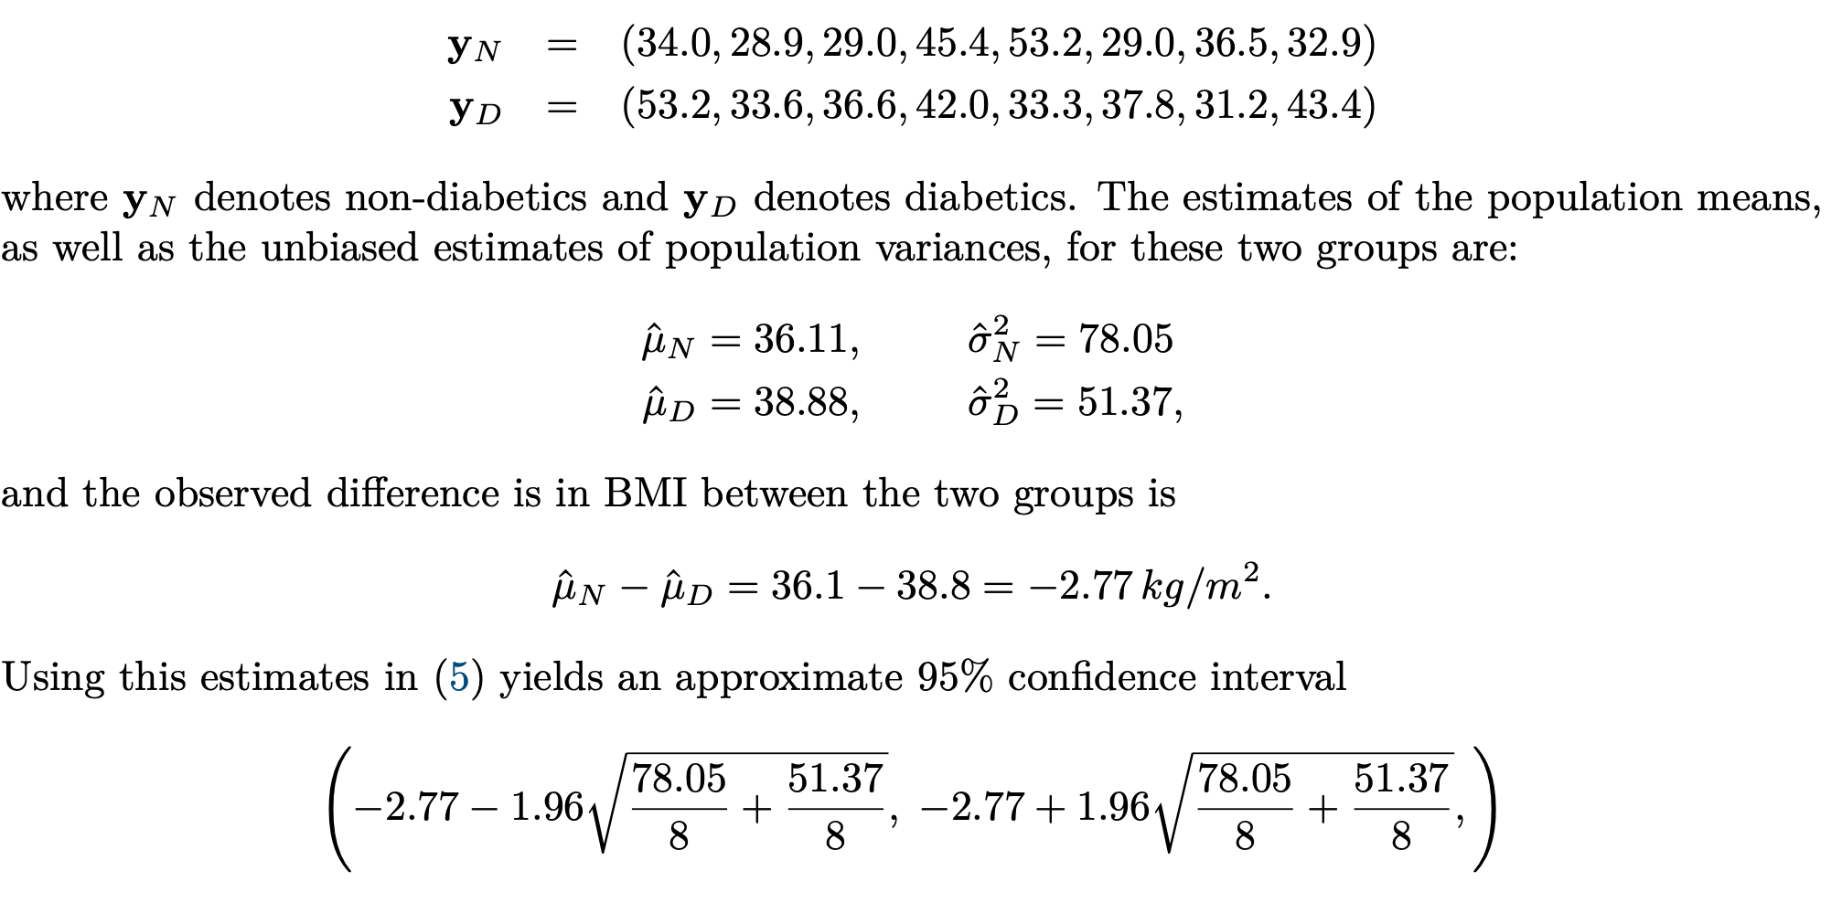

#### CI for Difference of Normal Means with Unknown Variances

Approximate Confidence Intervals (CIs) for sample means are intervals constructed around a sample mean to estimate the range within which the population mean is likely to fall, given a certain level of confidence. It's a way to quantify the uncertainty associated with our estimate of the population mean based on a sample.

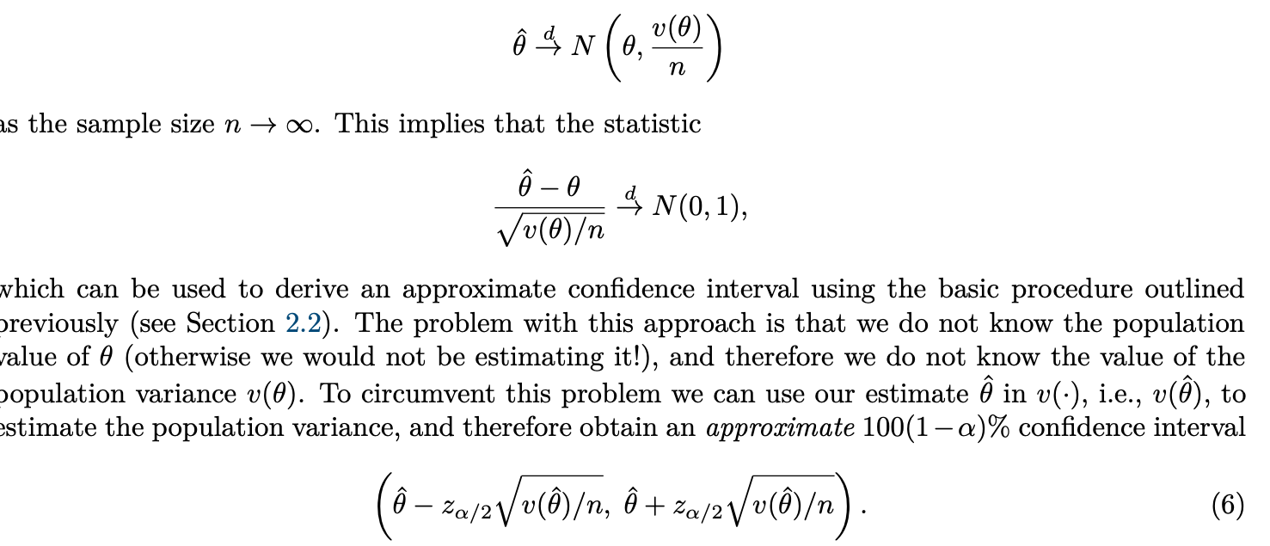

### Approximate CIs for sample means

#### Approximate CI for the Poisson Distribution

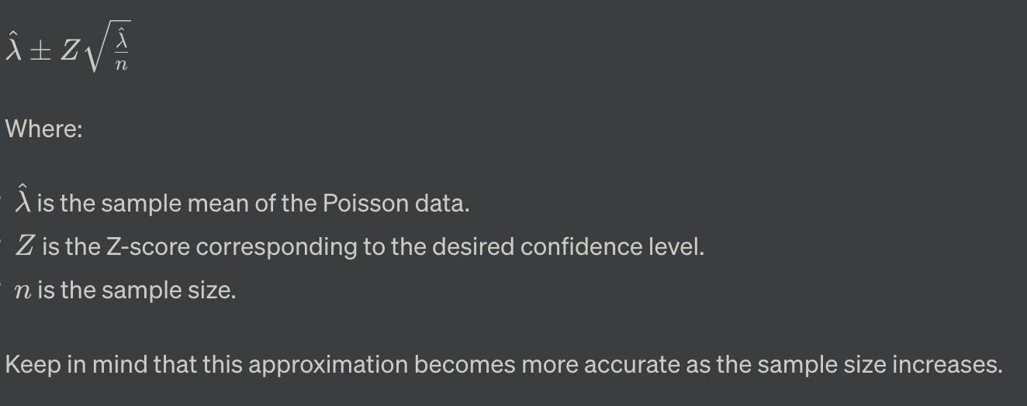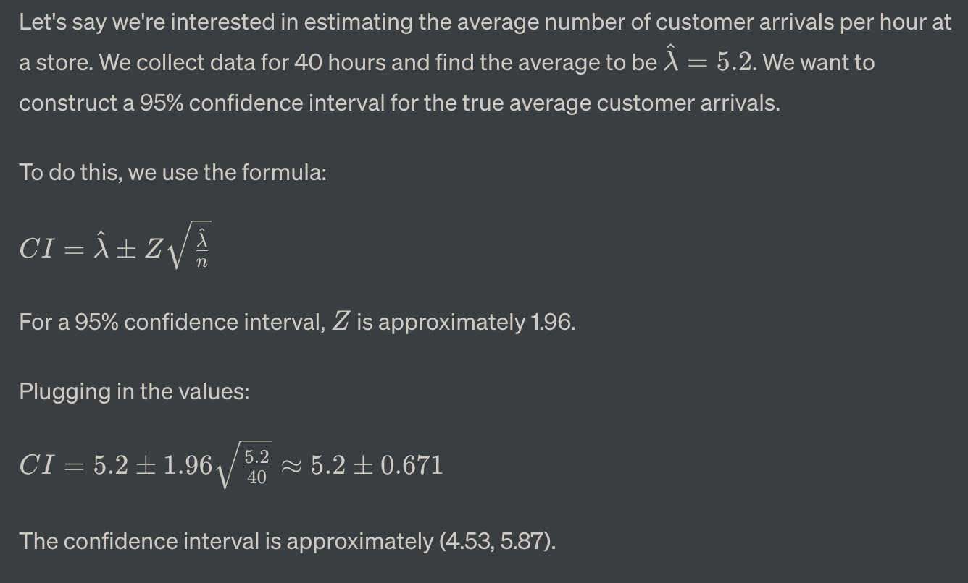

#### Approximate CI For the Bernoulli Distribution

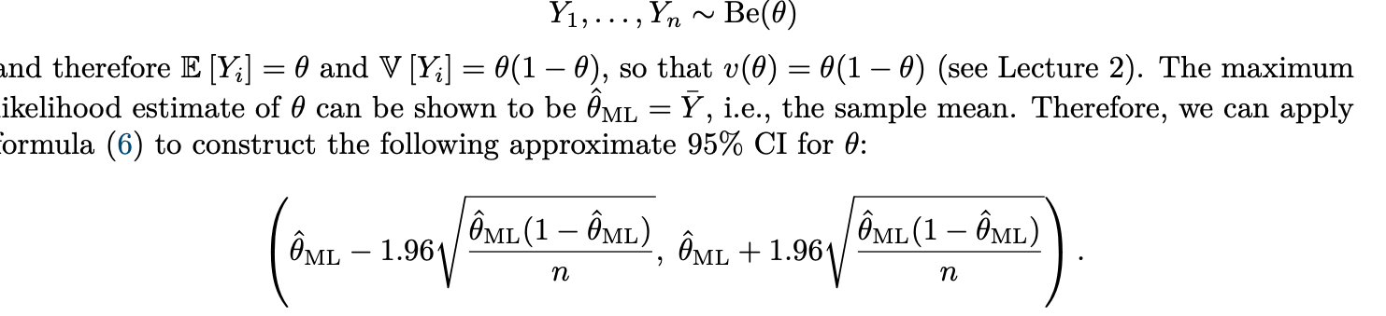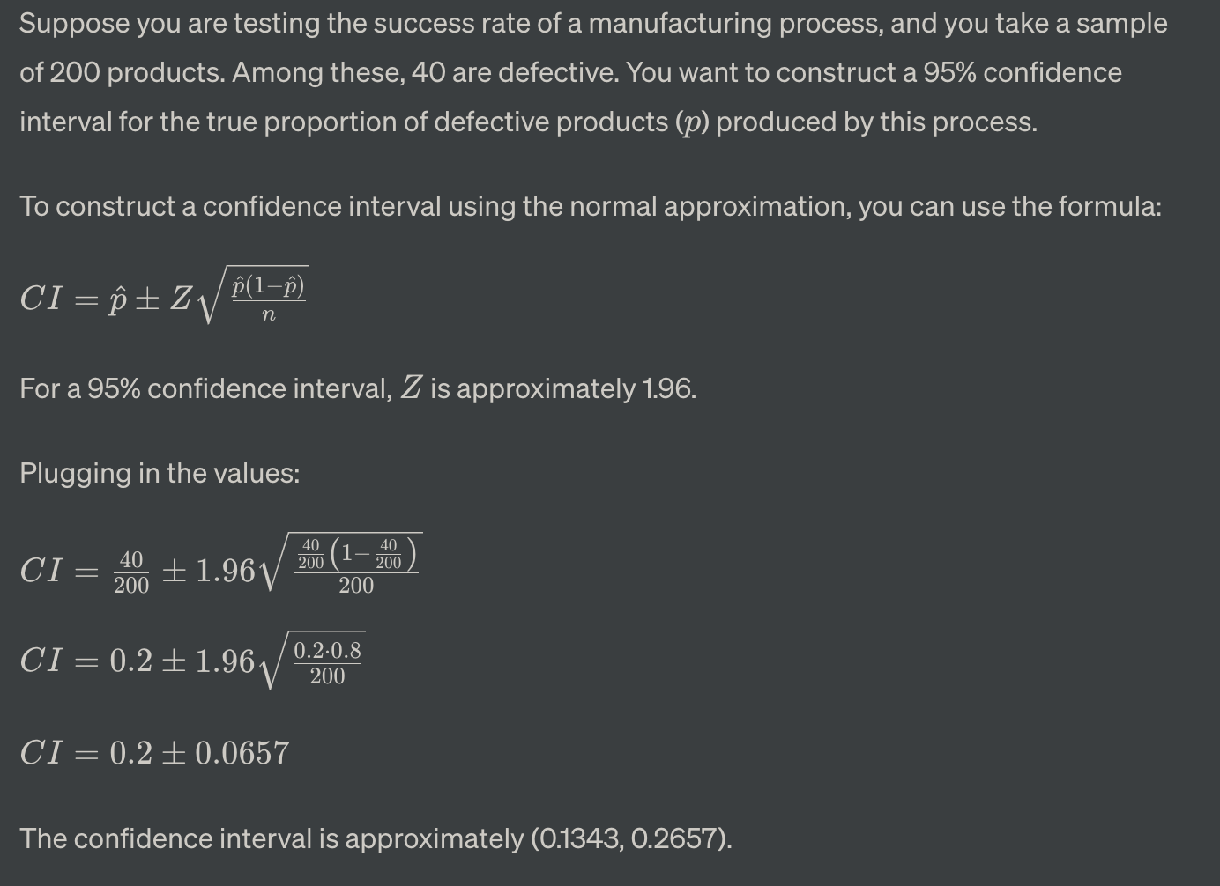

# Week 5 Hypothesis Testing

Hypothesis testing is a statistical method used to make inferences about a population based on sample data. It involves evaluating two competing statements about a population parameter, known as the null hypothesis and the alternative hypothesis. The goal is to determine whether there is enough evidence to support rejecting the null hypothesis in favor of the alternative hypothesis.

In this framework we take the null hypothesis to be our default position, and then ask how much evidence the data we have observed carries against this null hypothesis.

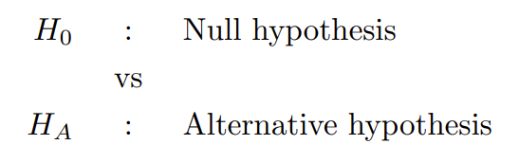 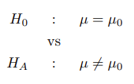



## Testing a normal distribution with known variance

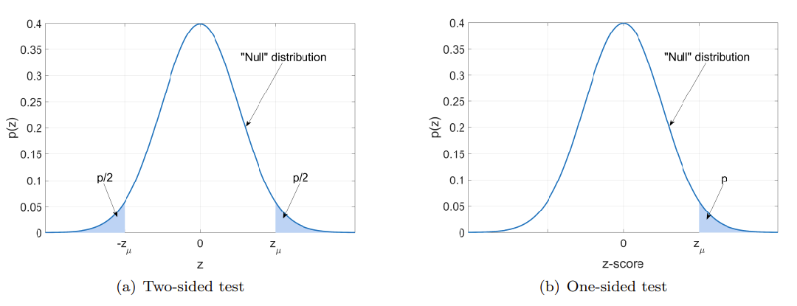 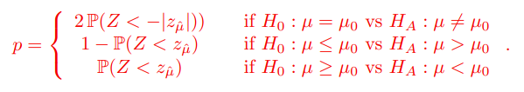

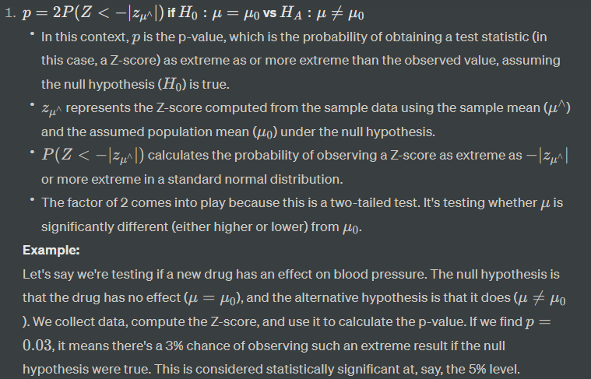 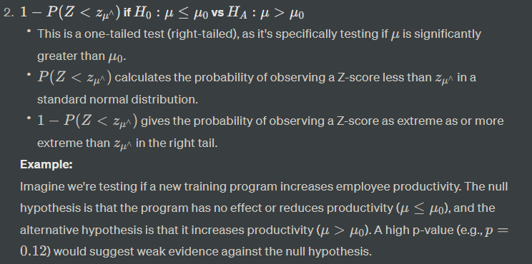 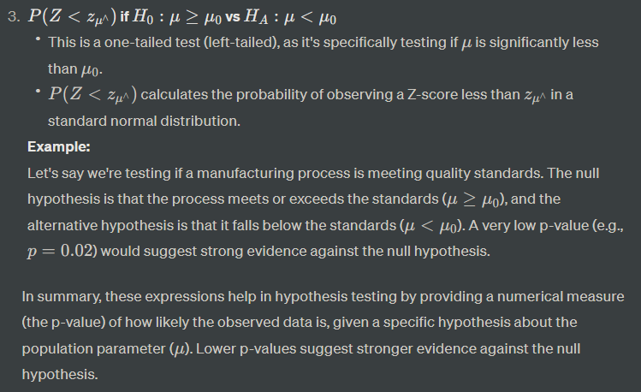

### Grading p-values and “significance”

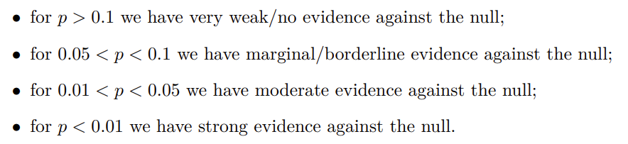

### Summary

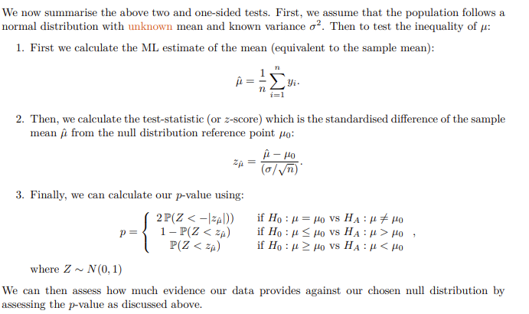

#### Example:

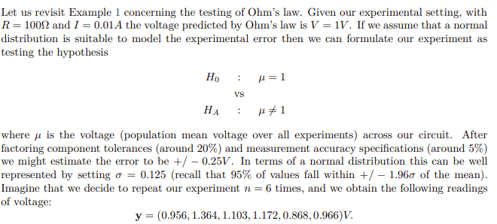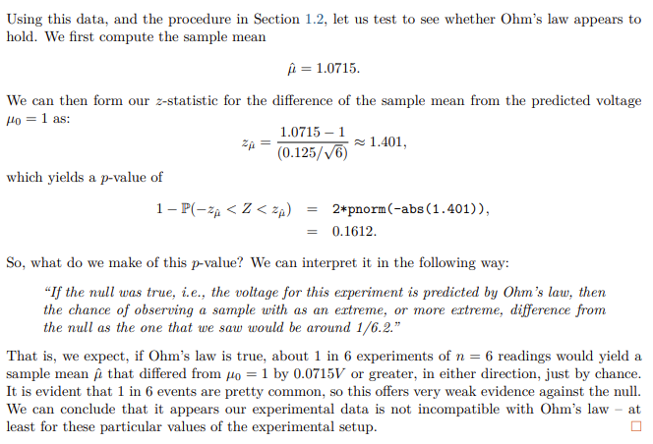

### Testing a normal distribution with unknown variance

Unknown mean and unknown variance

As we do not know the population variance, we must estimate it from our sample; we can use the unbiased estimate of variance

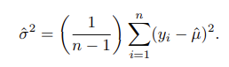

If we calculate the standardised difference of µˆ from our reference point µ0 using (3), with our estimate σˆ in place of the unknown population standard deviation σ, then we have a t-score

#### t-score

t-score, also known as a t-value or Student's t-score用于量化样本估计与其估计的总体参数之间的偏离程度used in hypothesis testing and confidence interval construction, especially when the sample size is small or when the population standard deviation is unknown

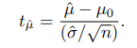

If the null hypothesis is true, then our t-score will follow

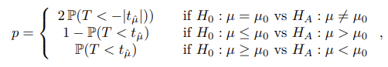

#### Difference between t score and z score

**Z分数**和**t分数**都是与数据分布相关的统计量，它们在不同的情况下使用，并基于不同的分布。



主要区别在于它们所基于的分布不同。Z分数基于标准正态分布，这是均值为0、标准差为1的正态分布的特例。T分数基于T分布，其形状根据样本量（具体来说是自由度）而变化。

## Testing the difference of means with known variances

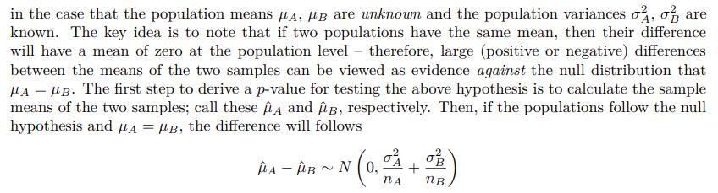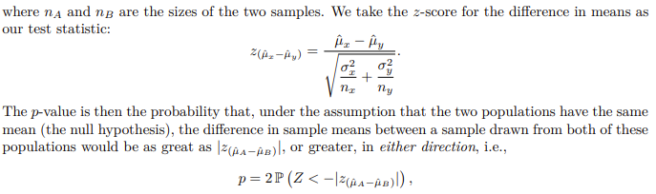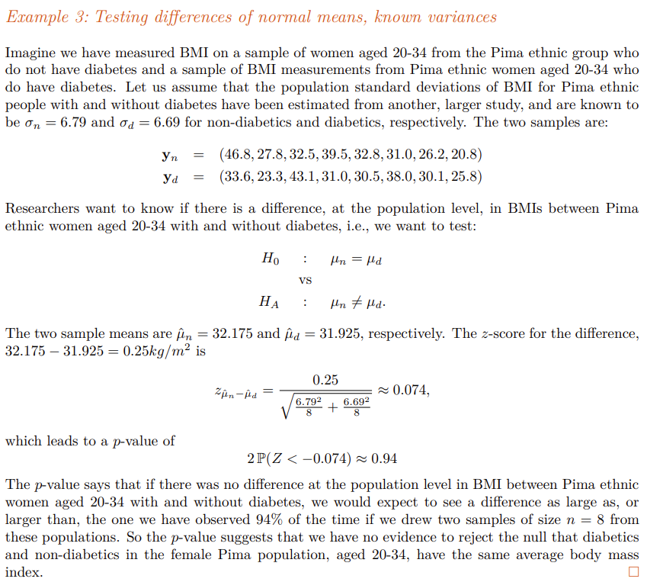

Testing the difference of means with unknown variances

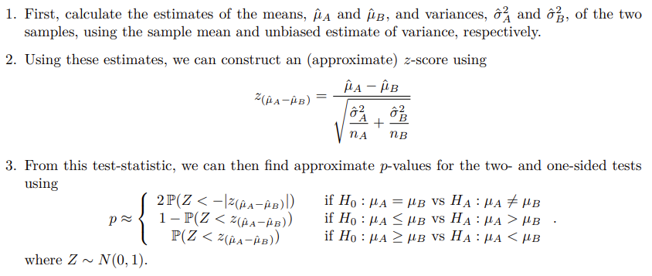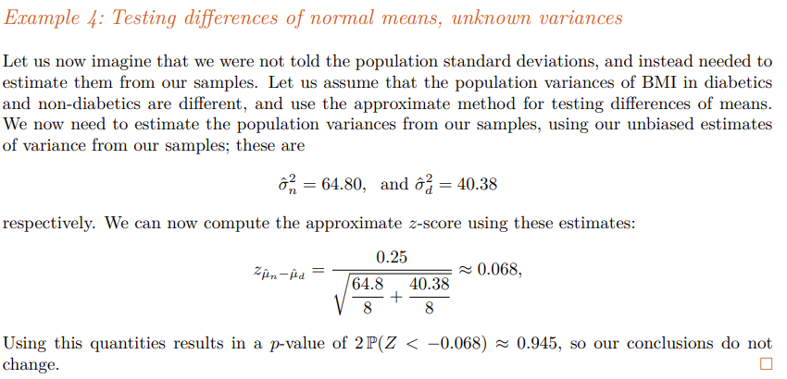

## Testing a Bernoulli Population

For example, consider a production line making certain electronic components. If the manufacturer guarantees that the failure rate of components is less than some amount θ0 – a requirement potentially needed to supply to customers like the military – then after obtaining a sample of the products in question, and observing the failure rate in that sample, a customer could test to see if the advertised failure rate was achieved.

### Tests for a Single Bernoulli Population

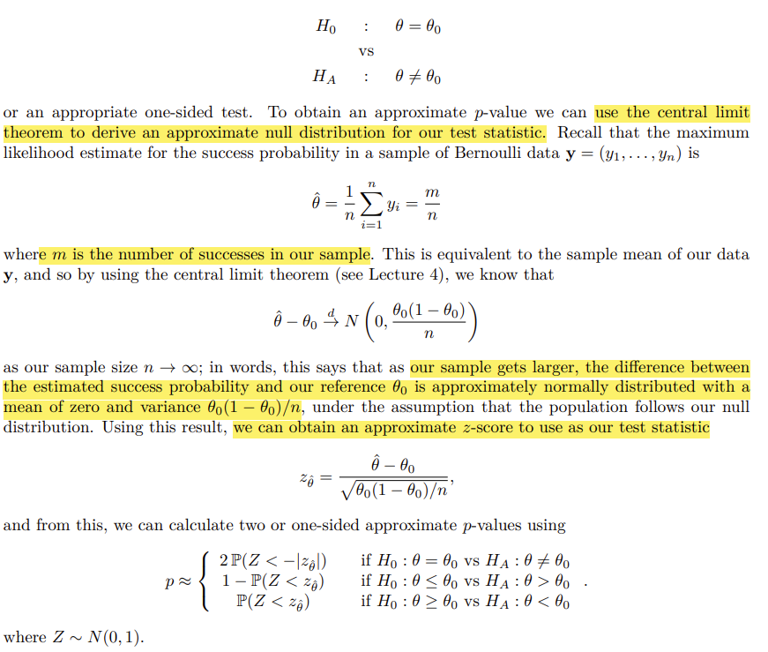

### Testing two Bernoulli populations

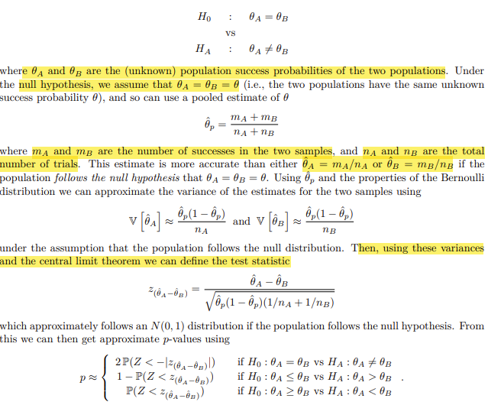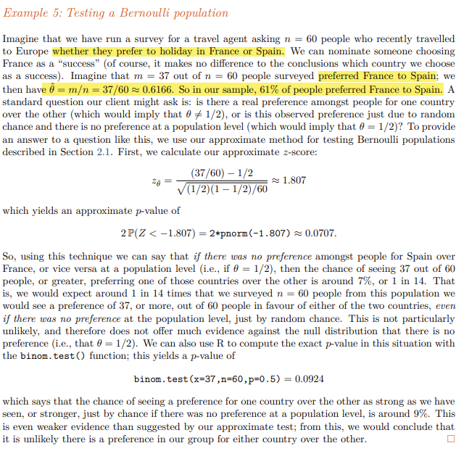

## Can we prove the null hypothesis?

the p-value represents evidence against the null only

if we experimentally measured the voltage for many repetitions with these settings, the data would also not be incompatible with the law.

# Week 6 Linear Regression

## Supervised Learning

Definition:

Supervised learning is trained on a labelled dataset, meaning that the input data is paired with the correct output. The algorithm learns to map the input data to the correct output by generalizing from the labelled examples.

Unsupervised learning is not provided with labelled output. Instead, it must find patterns or structures in the data on its own.

Supervised **Examples**:

* **Classification (**categorical**)** : This is when the output is a category, such as spam or not spam in email filtering, or whether an email is a work email or a personal email.
* **Regression (numerical)**: This is when the output is a continuous value, like predicting house prices based on features like square footage, number of bedrooms, etc.

Unsupervised E**xamples**:

* **Clustering**: Grouping similar data points together. For instance, in customer segmentation, you might group customers with similar purchasing behaviours.
* **Dimensionality Reduction**: Techniques like Principal Component Analysis (PCA) aim to reduce the number of features while retaining as much information as possible.
* **Anomaly Detection**: Identifying unusual patterns or outliers in the data.

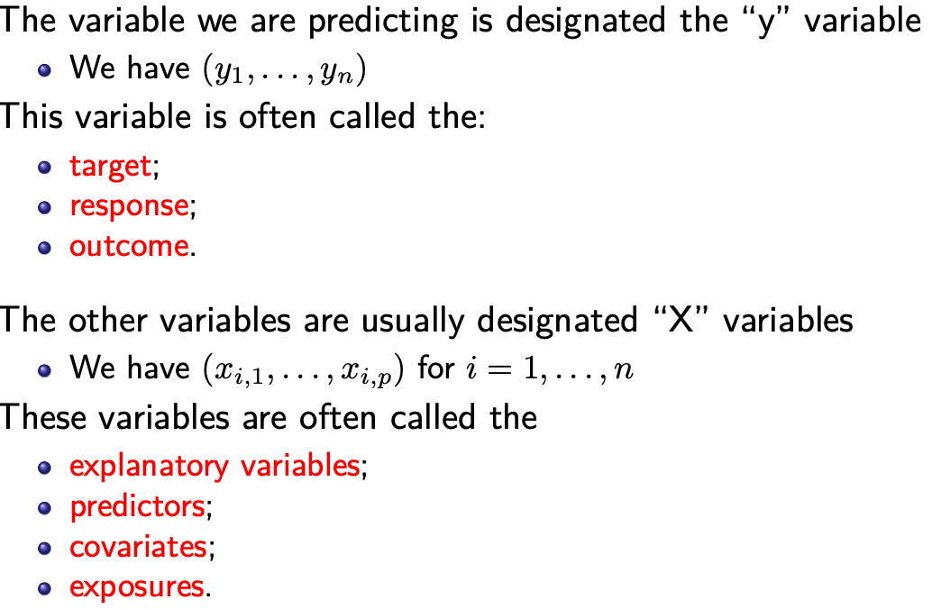

## Linear Regression

one of the most important:

(i) the linear model is highly interpretable, in the sense that it is easy to understand how the predictors effect the target, which makes it highly attractive in social and medical sciences;

(ii) despite its apparent simplicity, the humble linear model is very flexible and can even handle nonlinear relationships

(iii) its simplicity means that it is computationally efficient to fit, even for very large p

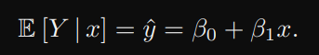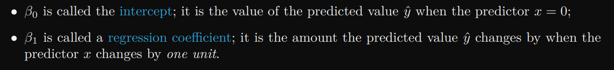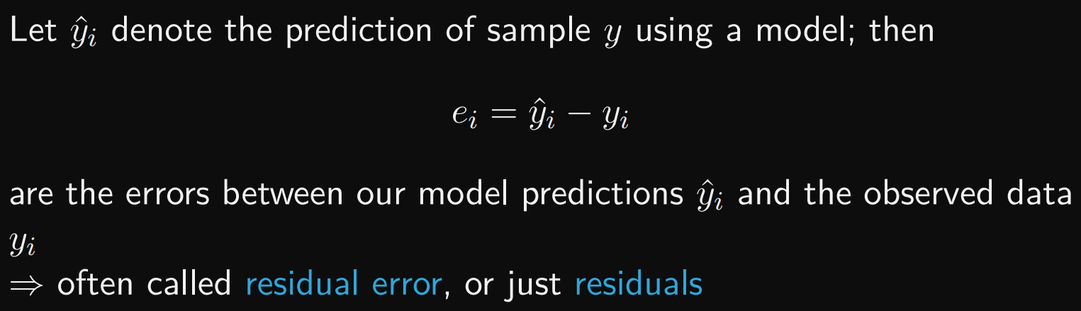

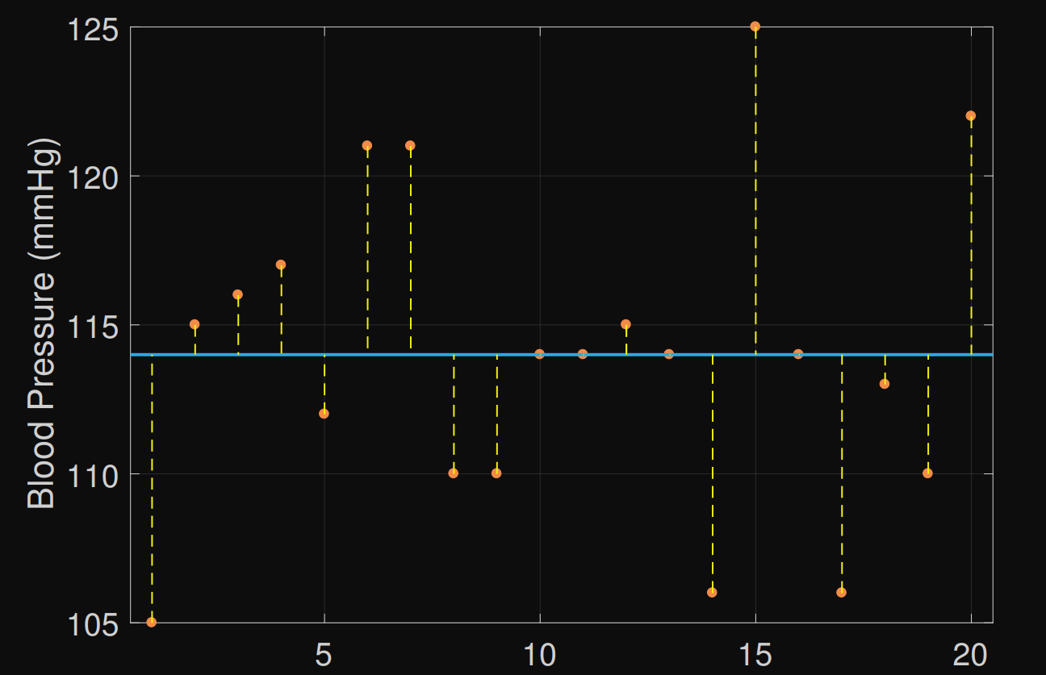

RSS (residual sum-of-squared errors):

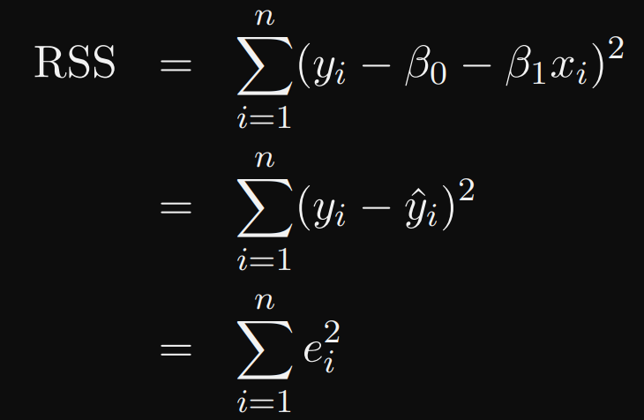

Yi: labelled correct value

Y_hat: value calculated by model

Smaller error = better fit

Therefore:

## The Principle of Least-squares

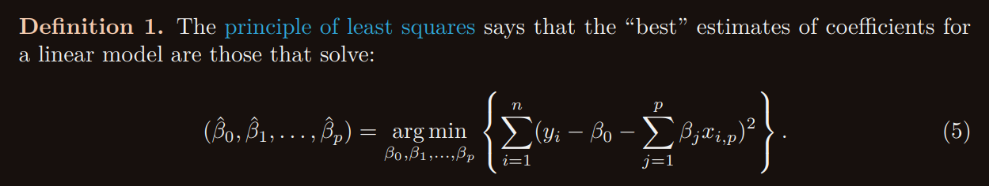

For linear regression:  
find the values of the coefficient and intercept for this simple linear model that result in the model that minimises the sum-of-squared errors (residuals) between the model predictions and the data values y.

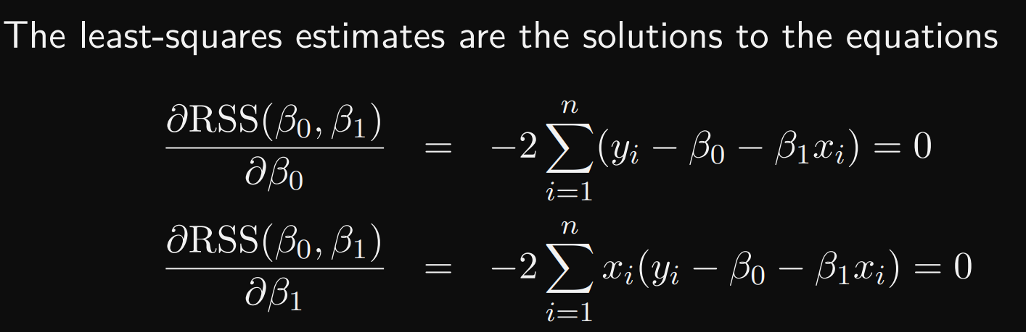

### Multiple Linear Regression

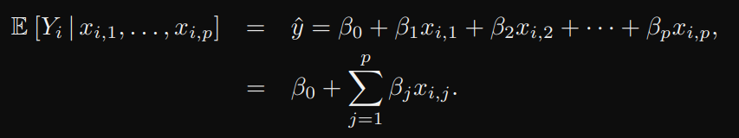

### R^2 values (R squared)

TSS:

This is called the “mean model”, as we predict every value of yi using the mean of the data y¯ only, without considering the effect of any predictors.

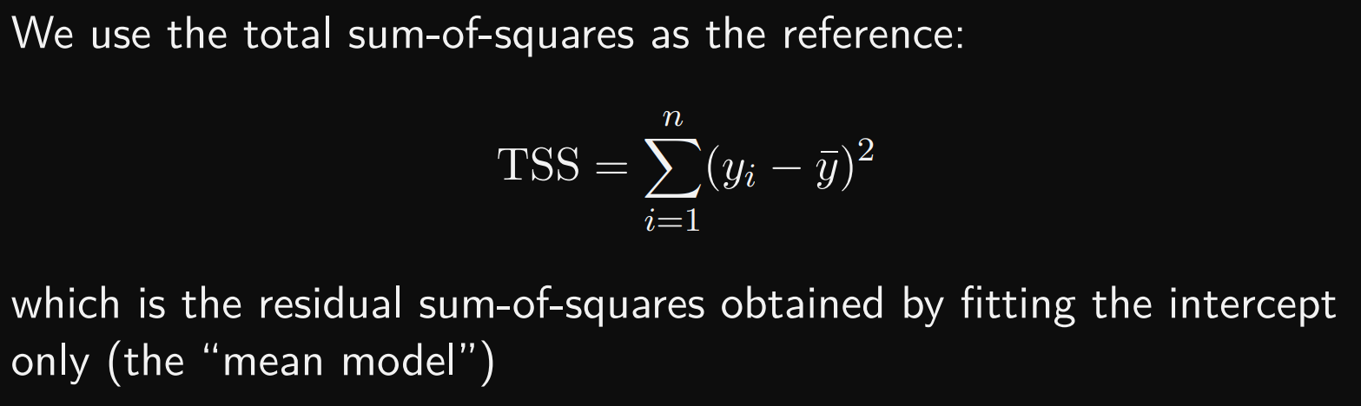

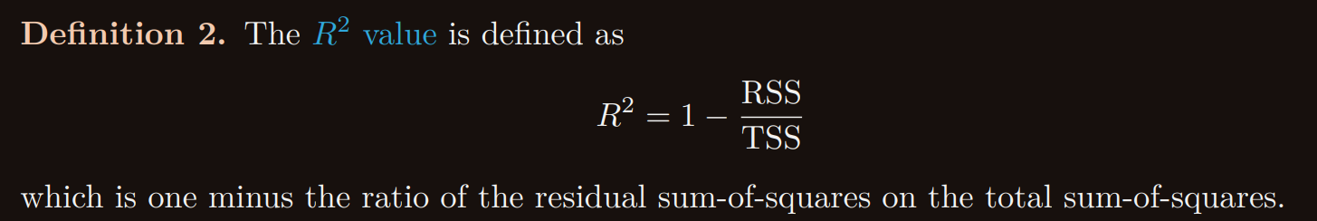

The closer the R2 is to one, the better the fit of the linear model to the data we have observed. Adding an extra predictor to a model, and estimating the coefficients using least-squares, always results in an increase in the R2 value.

The R2 value can never decrease with more predictors when using least-squares.

The R2 value can be used to determine important predictors by looking for those predictors that greatly increase R2 when added into a linear model.

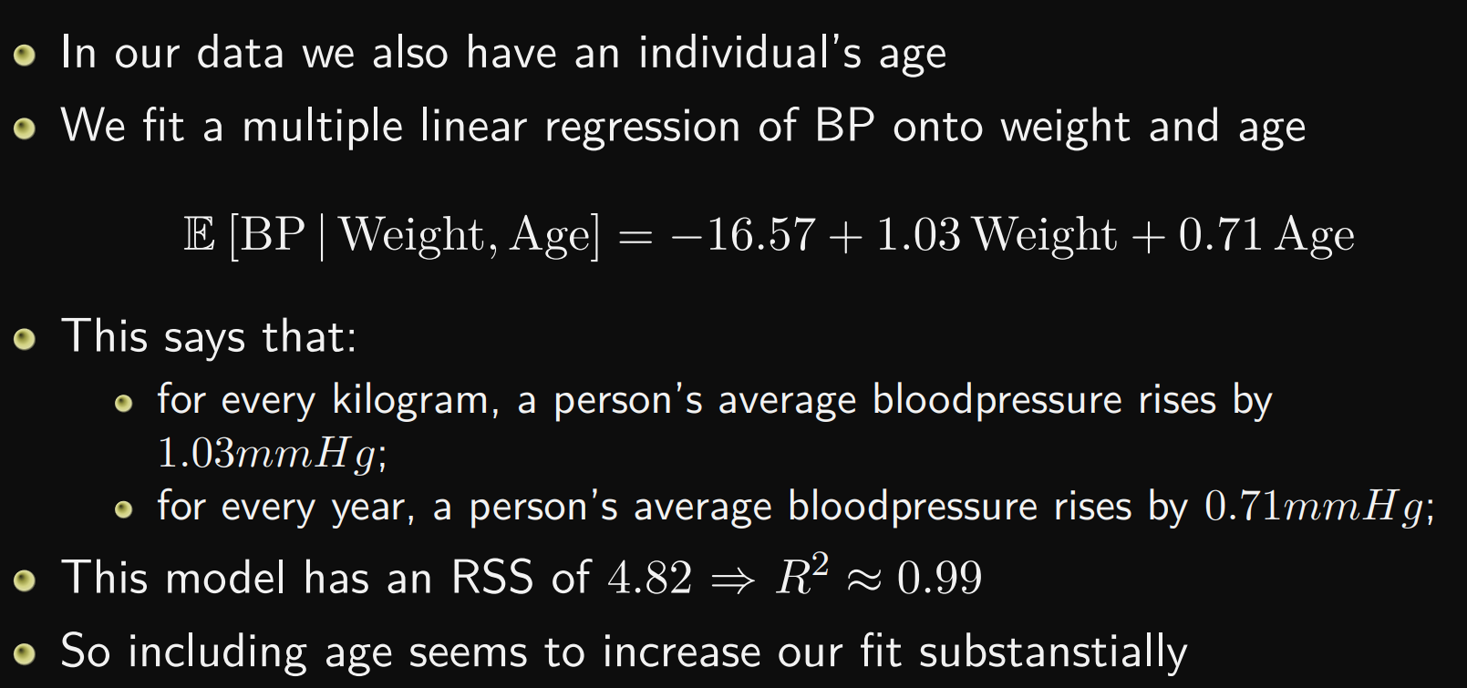

Example:  
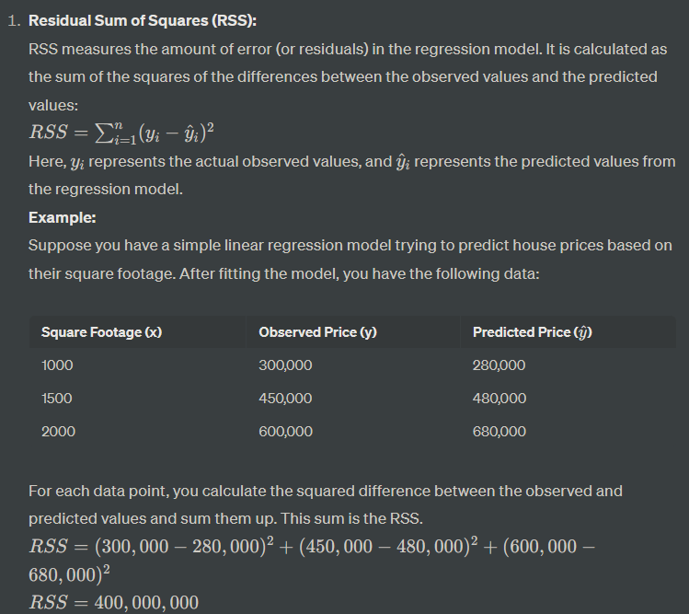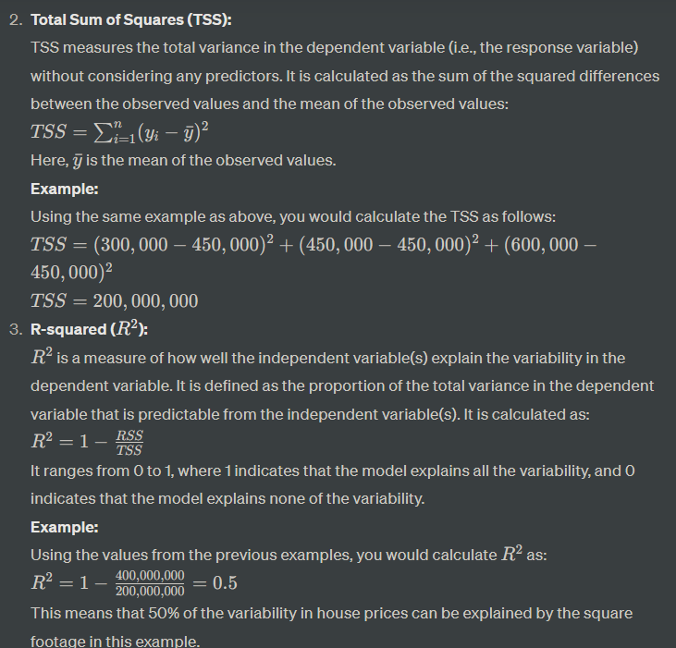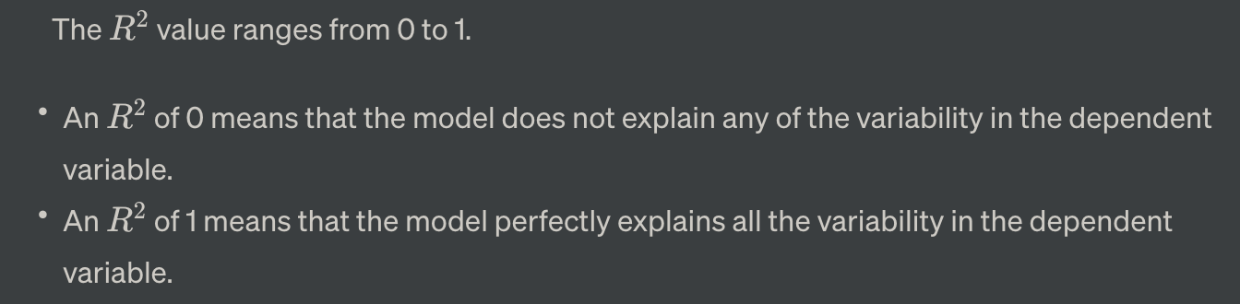

## Extensions

### Categorical predictors

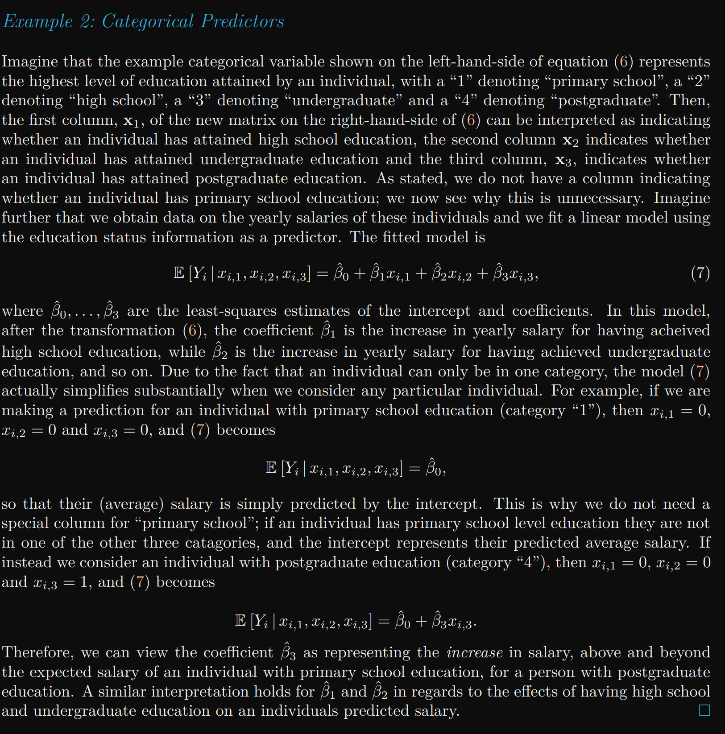

### Nonlinear Effects

Sometimes predictors are related to the target in a nonlinear fashion. If we transform our predictors appropriately they may become (approximately) linearly related to the target and our linear regression model will still be effective. 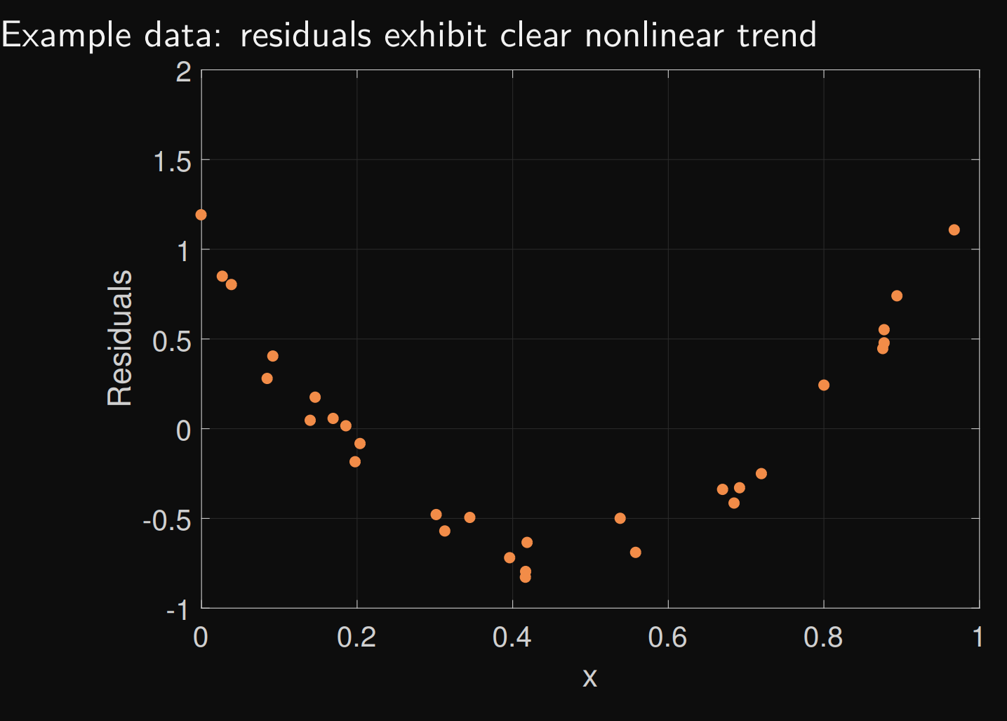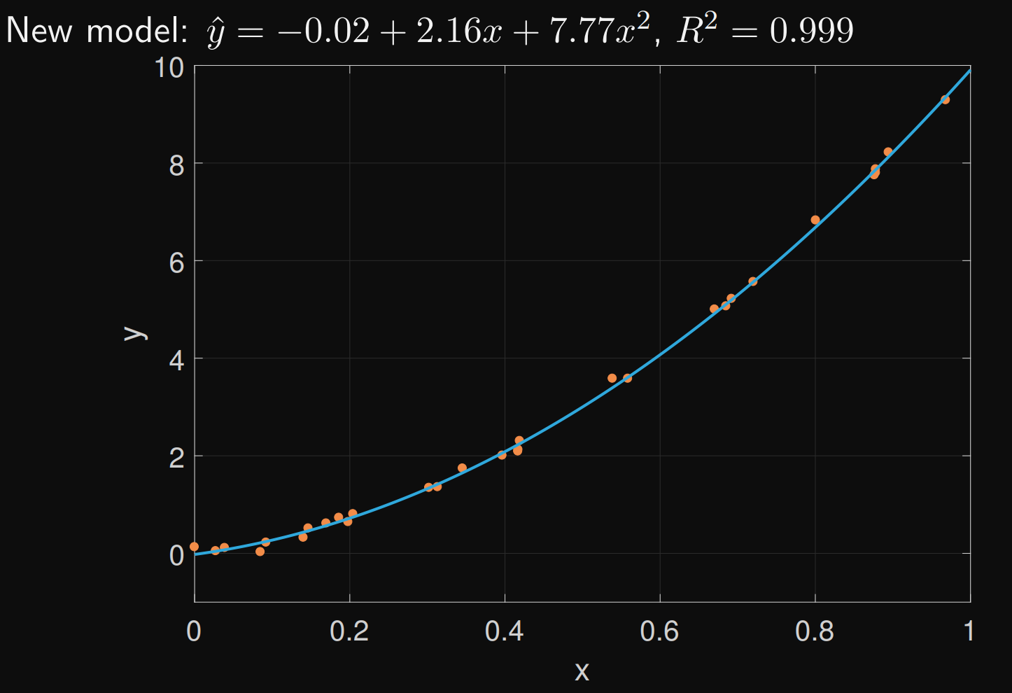

#### Logarithmic Transformations

#### Polynomial Transformations

## Selecting Predictors

### Overfitting and underfitting

Omitting important predictors Called underfitting Leads to systematic error, bias in predicting the target

Including spurious predictors Called overfitting Leads our model to “learn” noise and random variation Poorer ability to predict to new, unseen data from our population

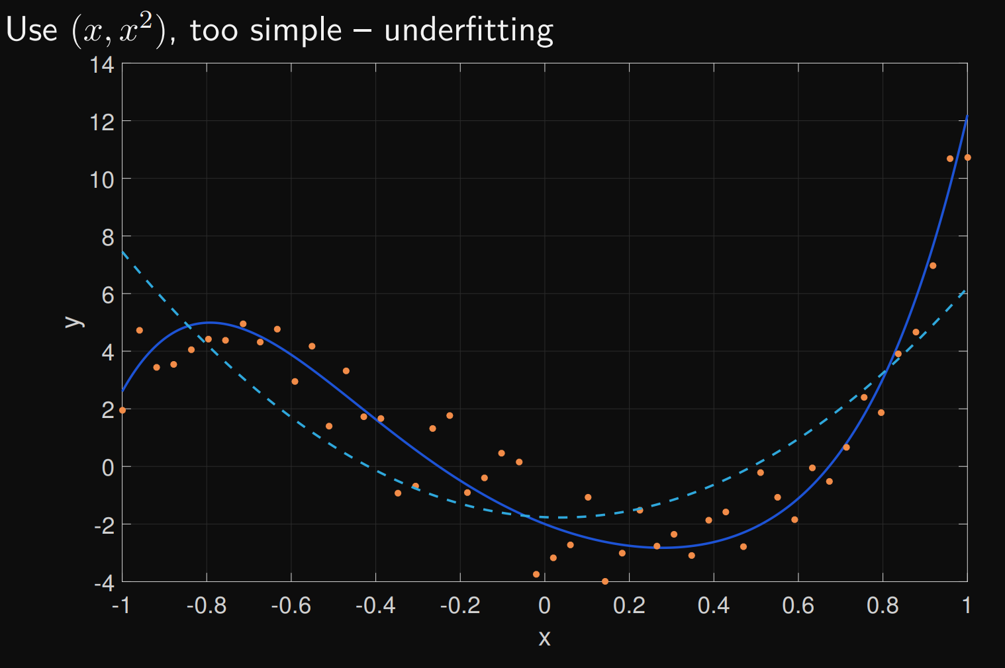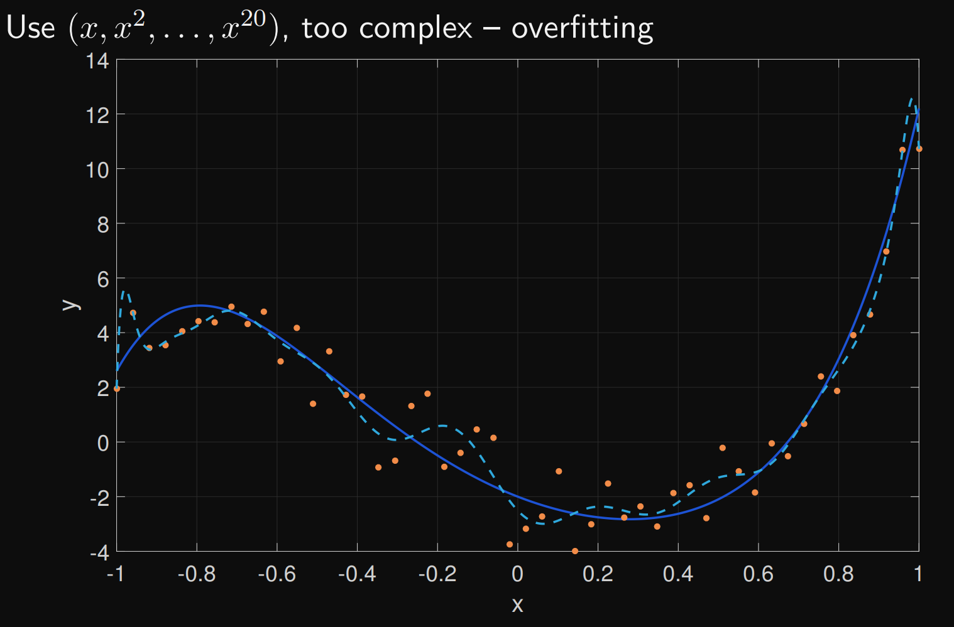

### Information Criteria

They provide a way to compare different models and help choose the best one for a given dataset. These criteria balance the goodness of fit of a model with the complexity of the model.

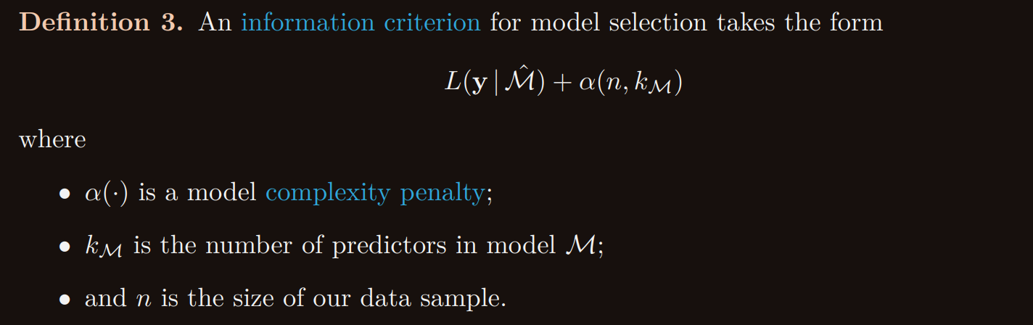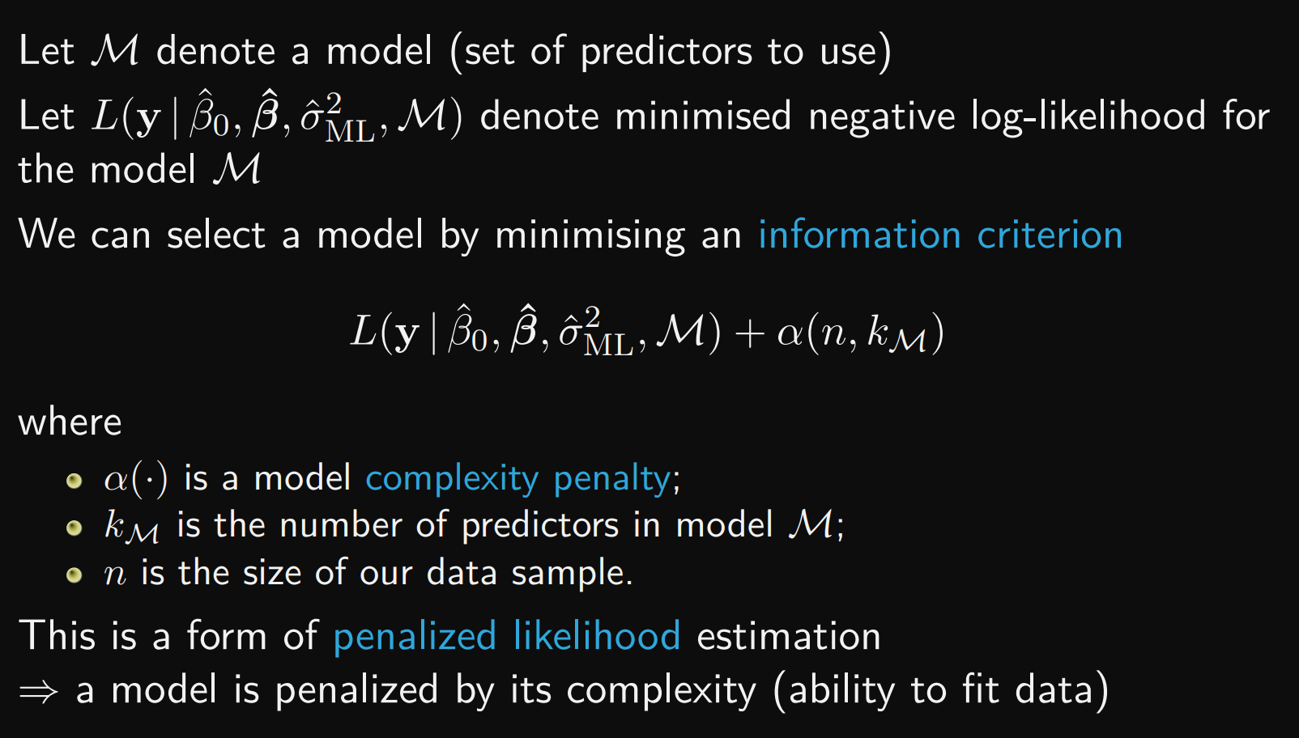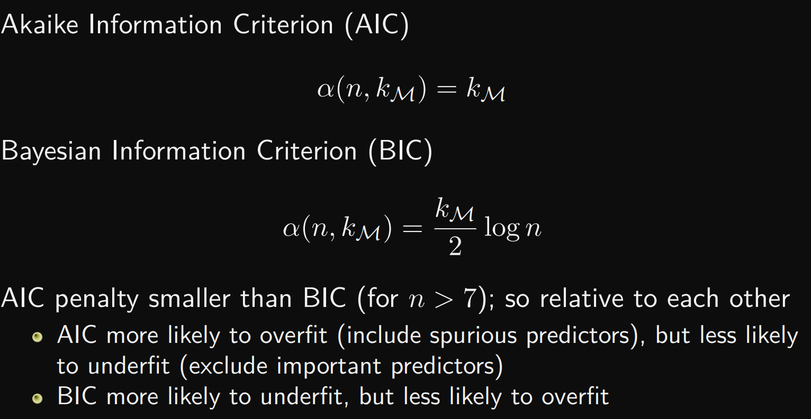

* **AIC** gives a measure of the relative quality of a statistical model for a given set of data. It balances the goodness of fit with the number of parameters. Lower AIC values indicate a better model.
* **BIC** is like AIC but penalizes models with more parameters more severely. It tends to favor simpler models over complex ones.

### Finding a good model

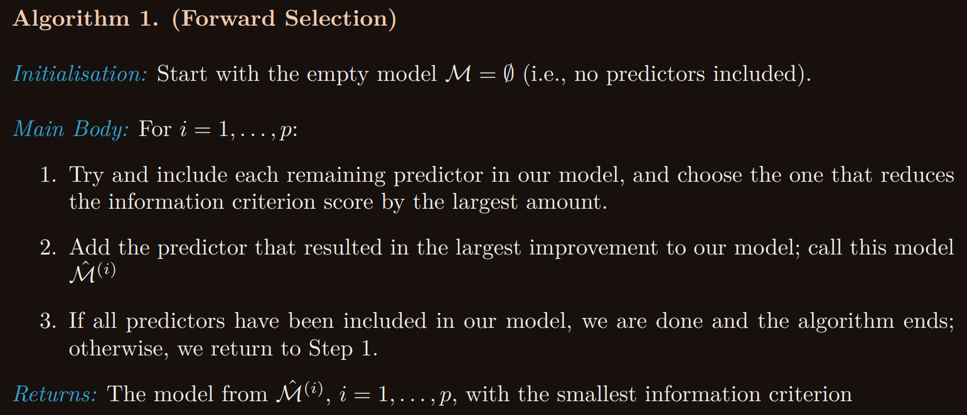

Backwards selection is related algorithm Start with the full model and remove predictors

# Week 7 Classification and Logistic Regression

## Classifiers

supervised learning method

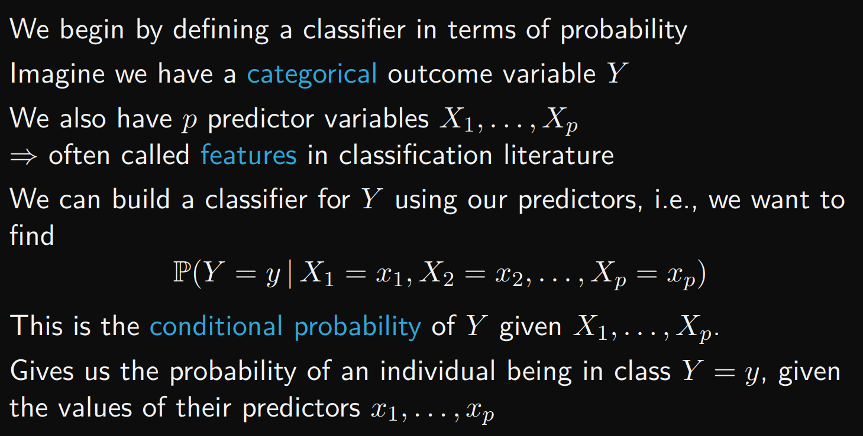

### Direct Construction

The formula for conditional probability is:

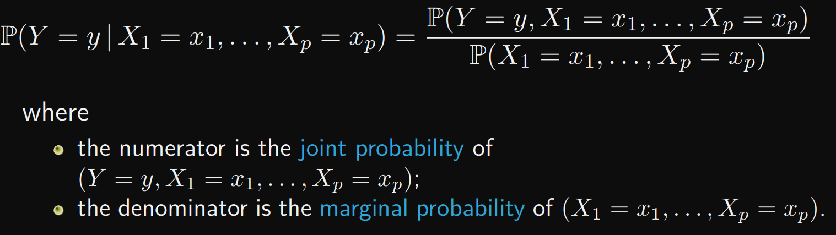

Example:

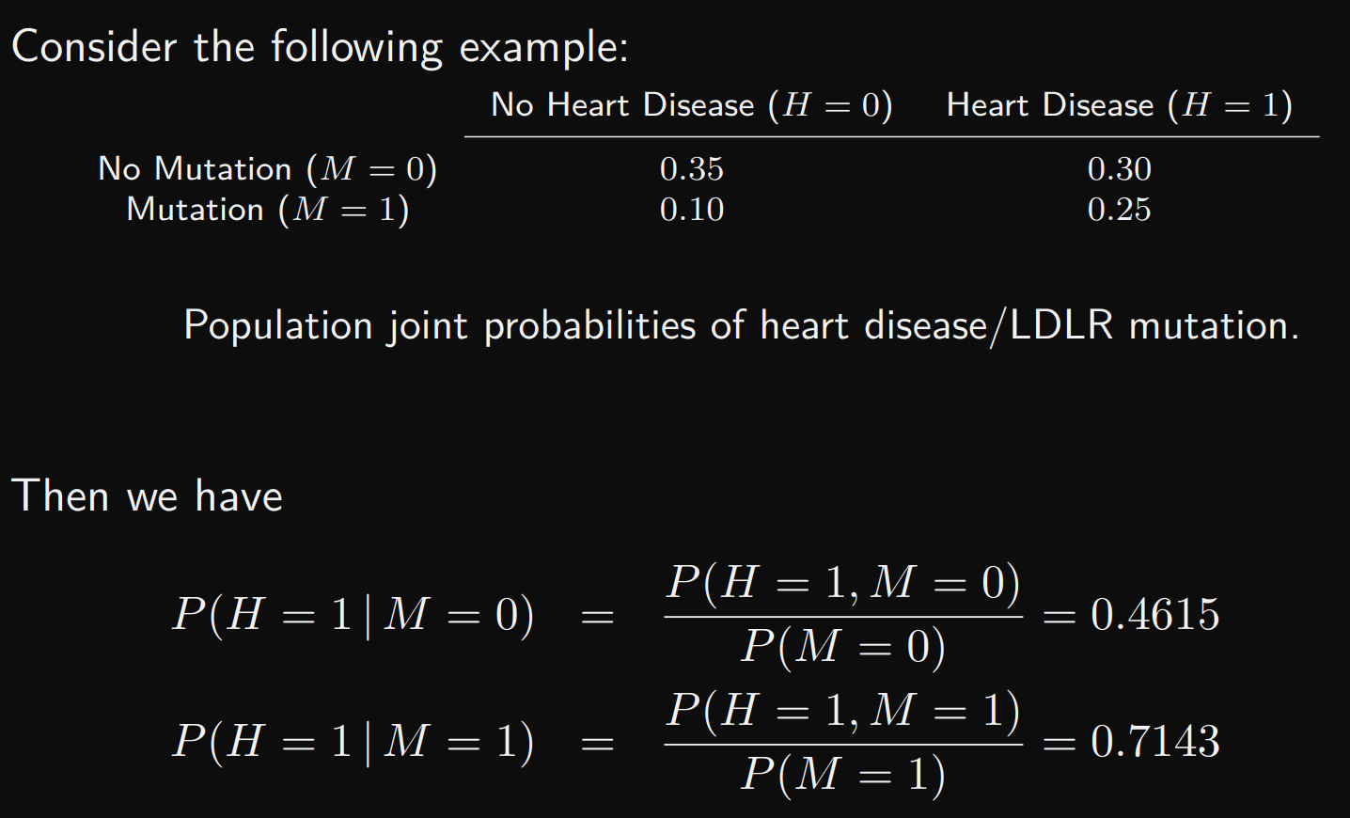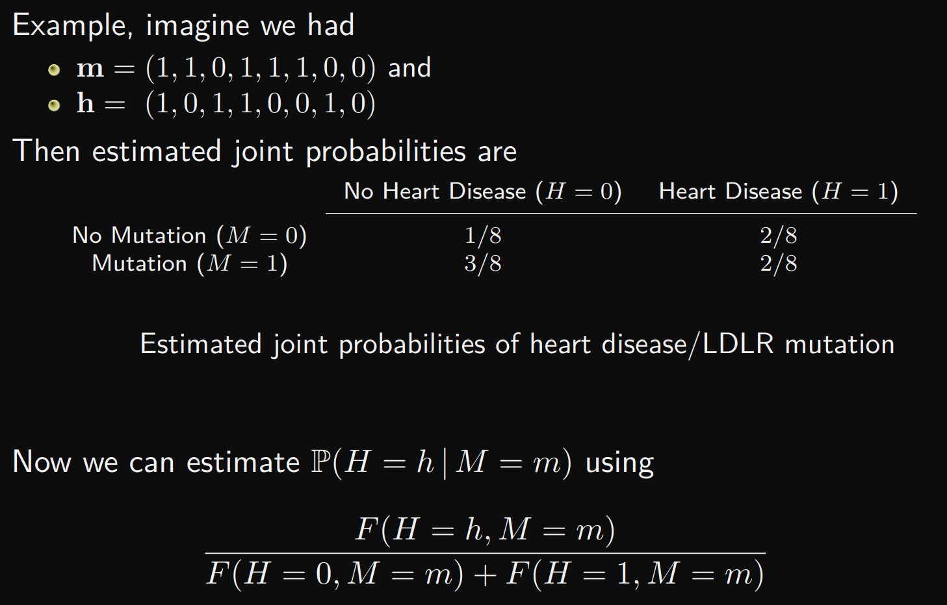

but there is a problem

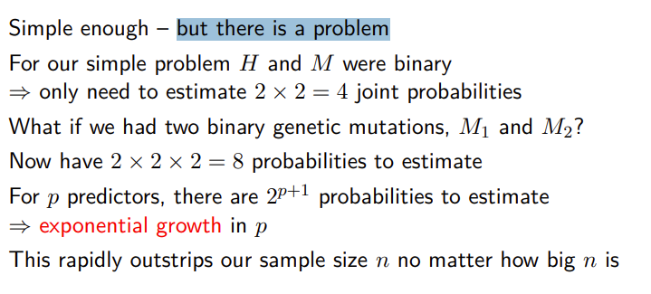

### Learning Simple Classifiers

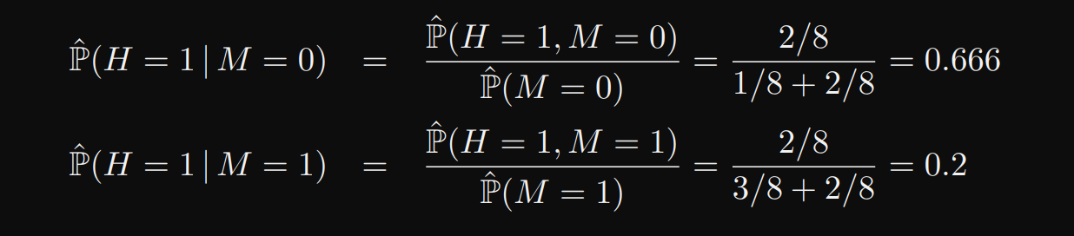

### Classifiers as Conditional Probabilities

## Logistic Regression

Adaptation of the linear model, widely used Directly estimates conditional probabilities Handles categorical and continuous predictors More difficult to handle multi-class targets

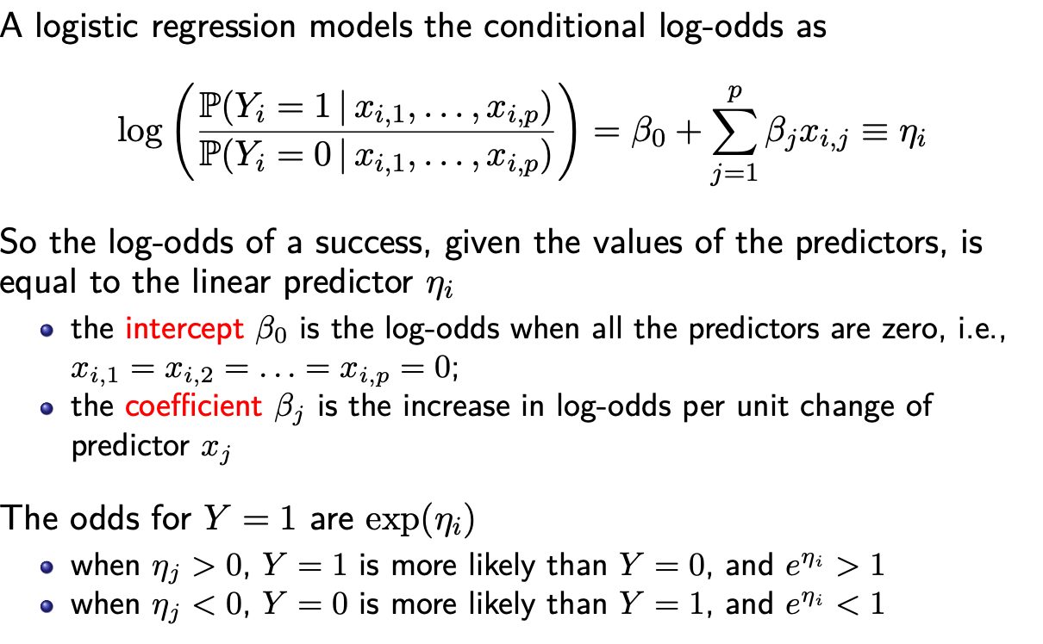

### Linear Predictors

Linear predictors vs nonlinear

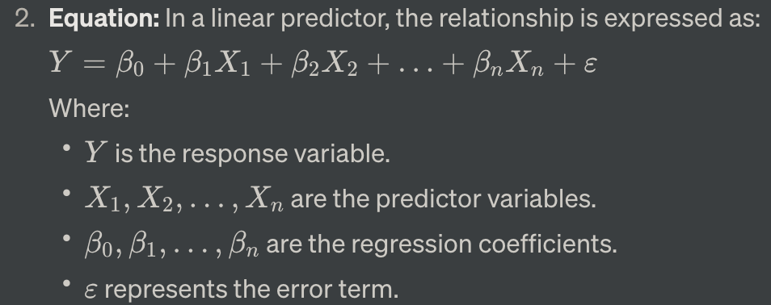

**Examples:** Simple linear regression (one predictor variable), multiple linear regression (multiple predictor variables).

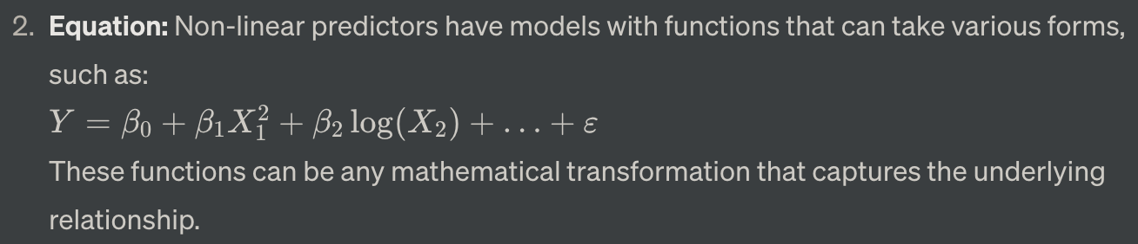

**Examples:** Polynomial regression, exponential regression, logistic regression (for binary outcomes).

### Logistic Regression

逻辑回归的主要思想是将线性模型与逻辑函数（或称为Sigmoid函数）结合起来，从而将线性输出映射到一个0到1之间的概率范围内。该概率表示某个样本属于某一类别的可能性。

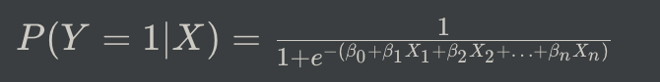

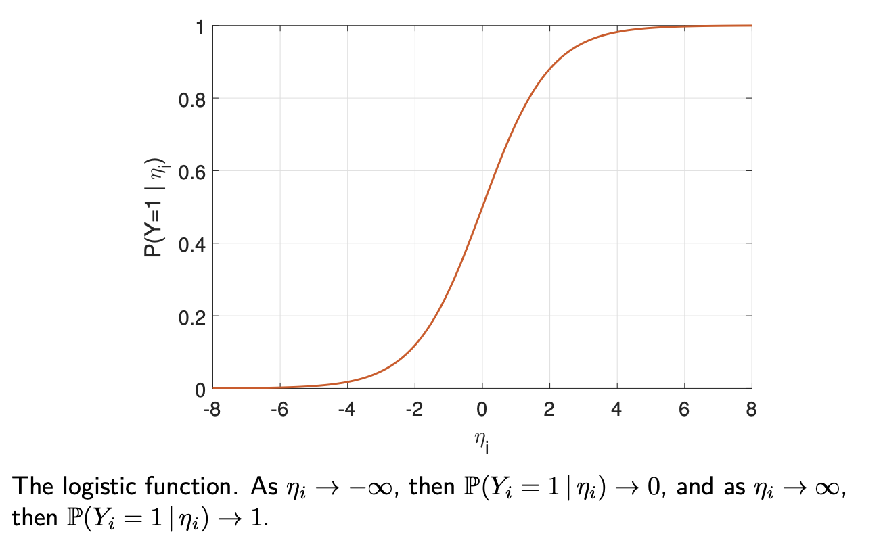

### Logistic Regression and Log-Odds

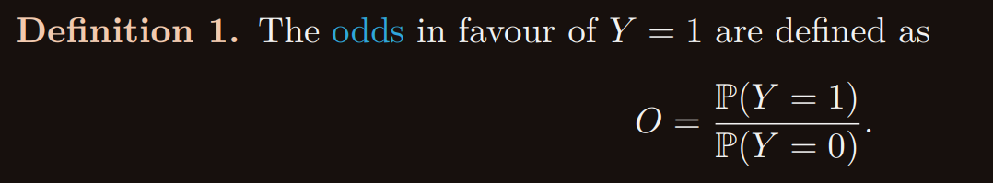

The odds describes how many times more likely Y is to take on the value 1 (i.e., a success) than it is to take on a 0 (i.e., a failure).

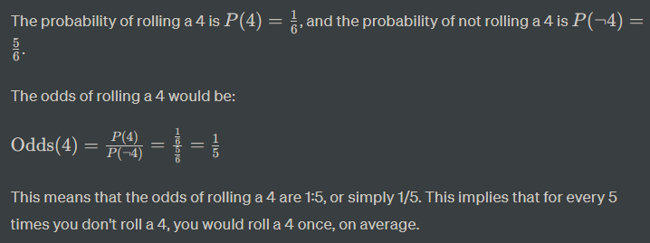

Log-odds（对数几率）是逻辑回归模型中的一个重要概念，它表示某事件发生的概率与不发生的概率之比的对数。在逻辑回归中，我们使用log-odds来建立模型，然后通过将其转换为概率来做出分类预测。

数学上，log-odds可以表示为：

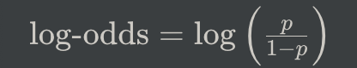

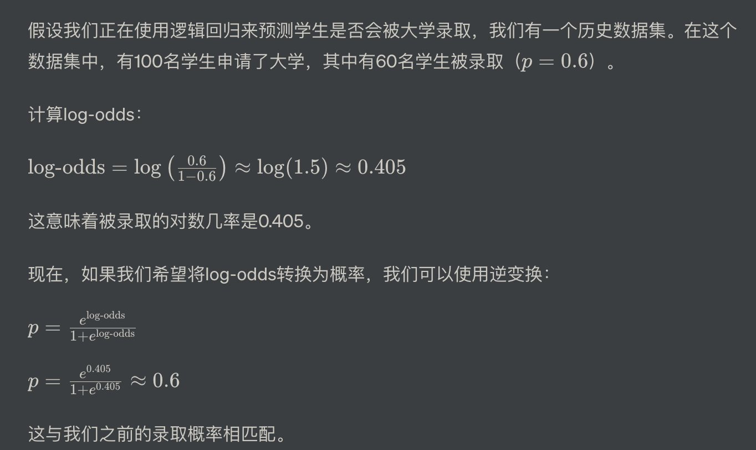

### Estimating Logistic Regressions

### Assessing Fit and Selecting Models

### Predicting with a Logistic Regression

## Assessing Classifiers

### Making predictions

### Classification Accuracy, Sensitivity, Specificity

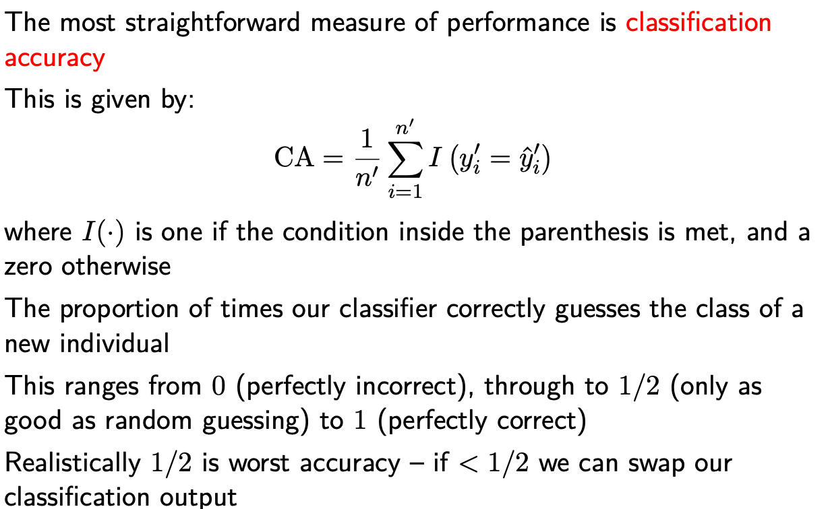

the classification accuracy can be derived from this information using: 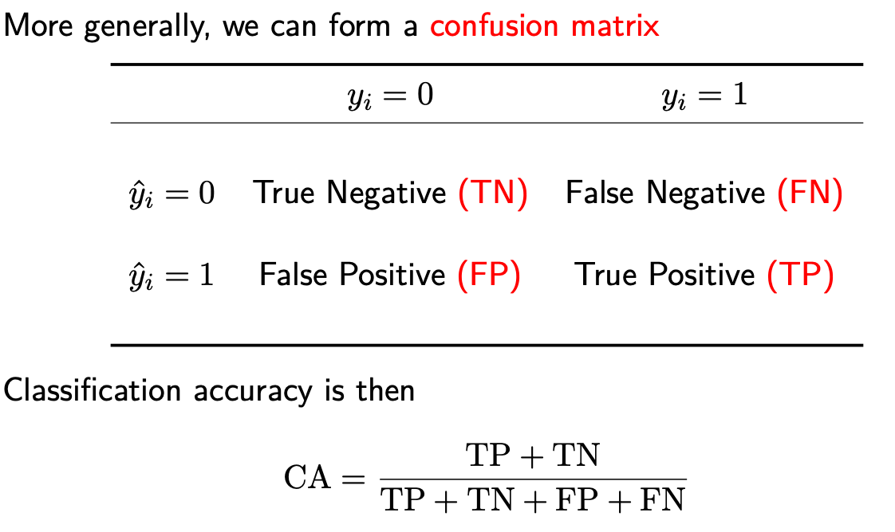

Specificity and Sensitivity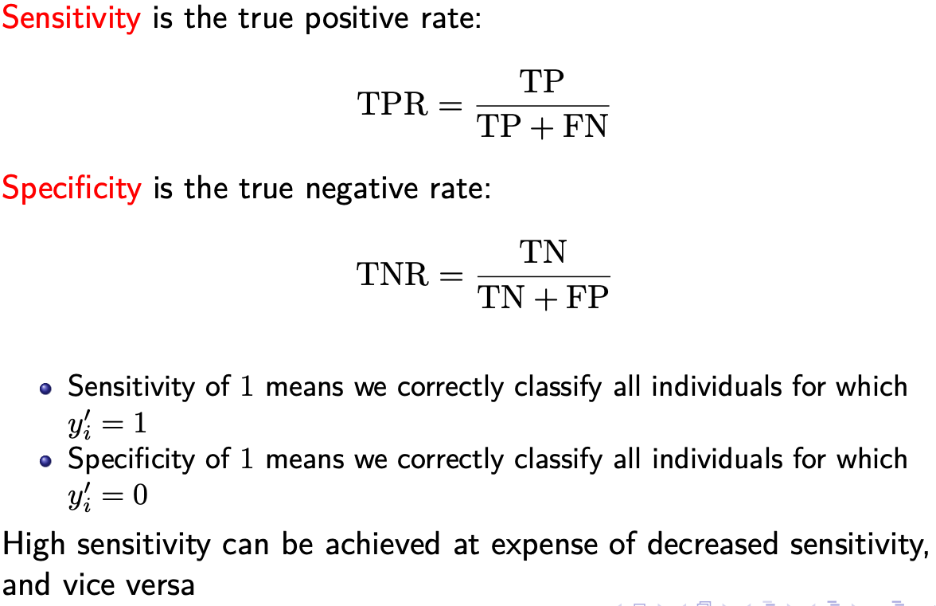

### Area-under-the-curve

We can plot these different values to get a “reciever operating curve”. The bigger the area, the better the classifier 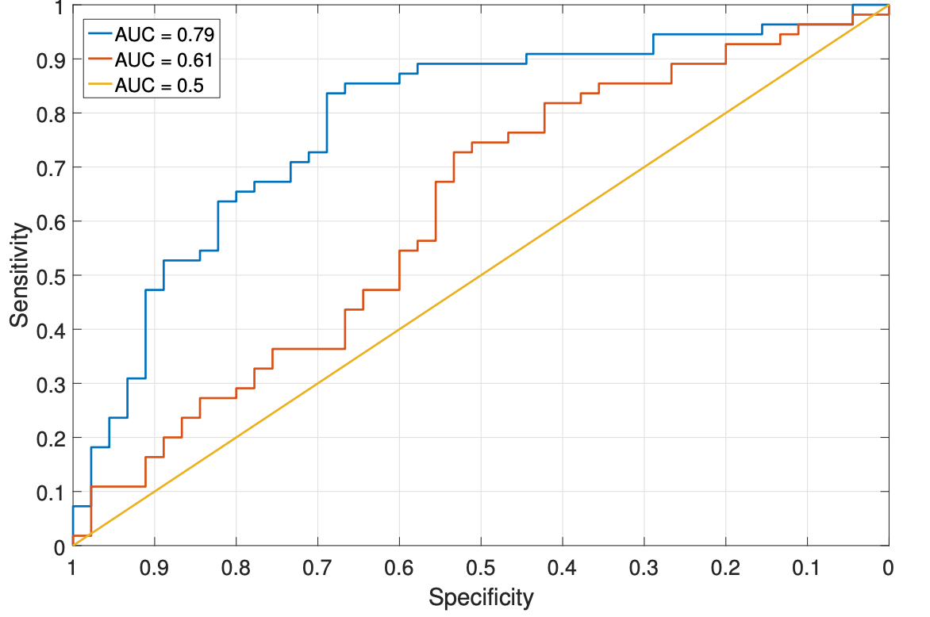 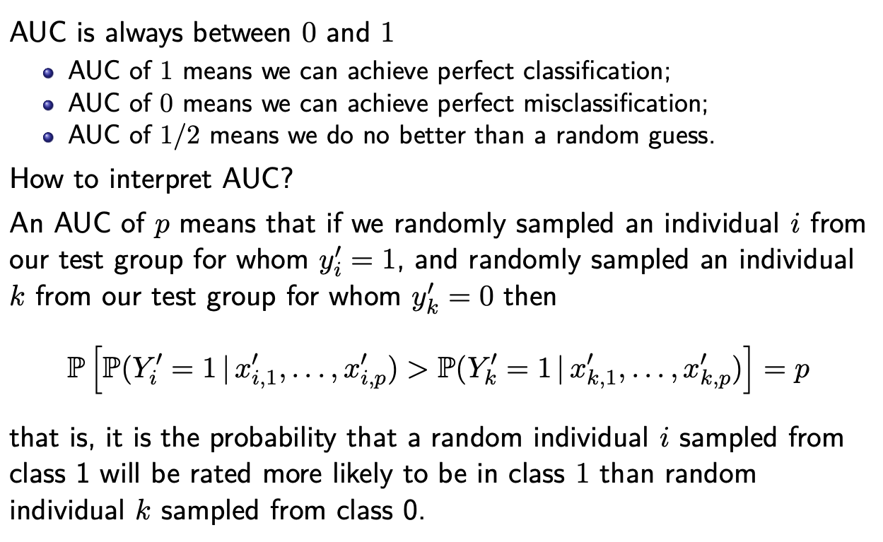

### Logarithmic Loss

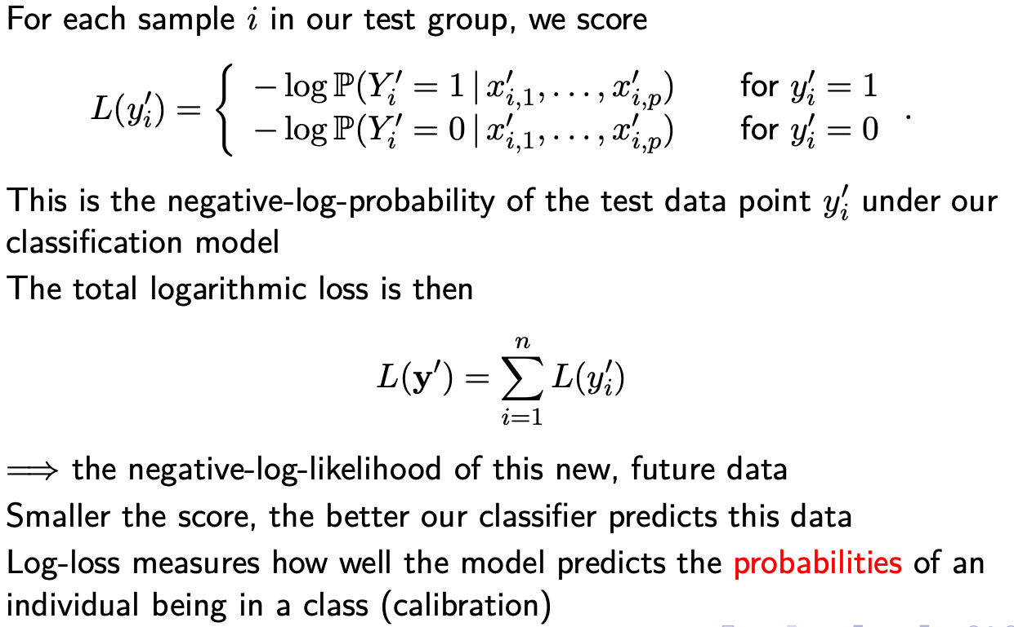

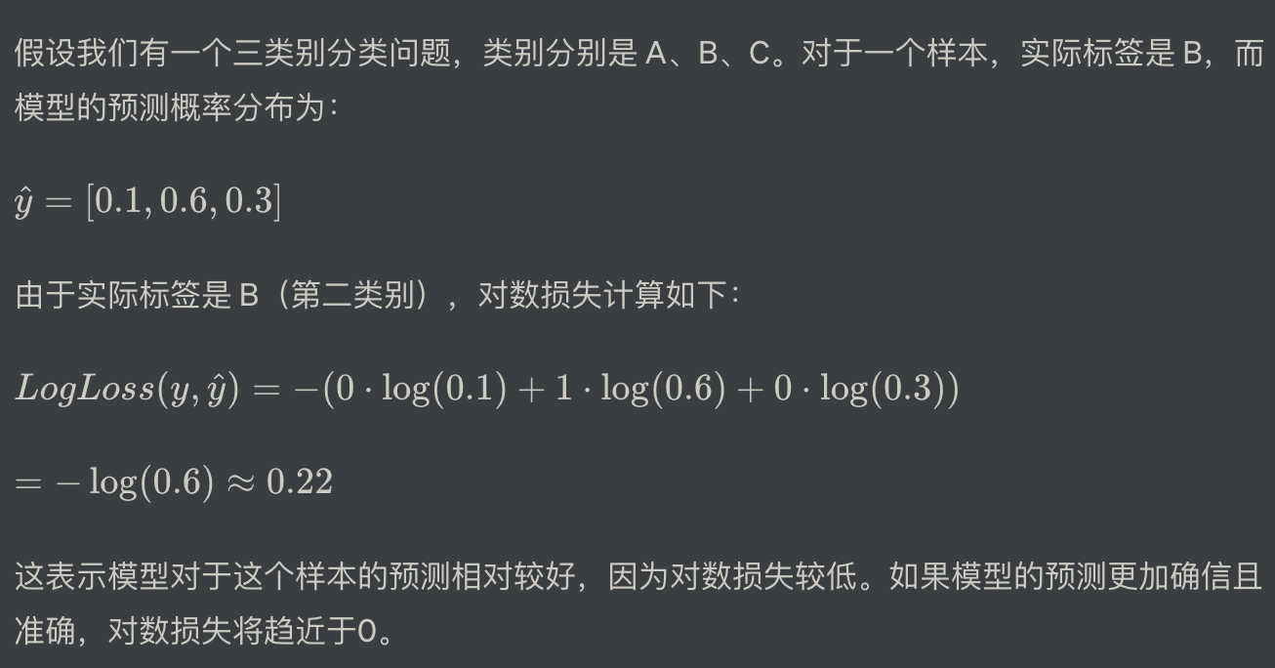

# Week 8 Model Selection and Penalized Regression

## Mean-Squared Prediction Error

The Mean Squared Prediction Error (MSPE) is a measure used to evaluate the performance of a predictive model. It quantifies the average squared difference between the predicted values and the actual values of a dataset. The lower the MSPE, the better the model is at making accurate predictions.

1. **Calculate Predicted Values:** Use the predictive model to generate predictions for each data point in the dataset.
2. **Calculate Residuals:** For each data point, subtract the predicted value from the actual value. These differences are called residuals.
3. **Square and Sum the Residuals:** Square each residual and then sum them all together.
4. **Average the Squares:** Divide the sum of squared residuals by the total number of data points to get the mean squared error.

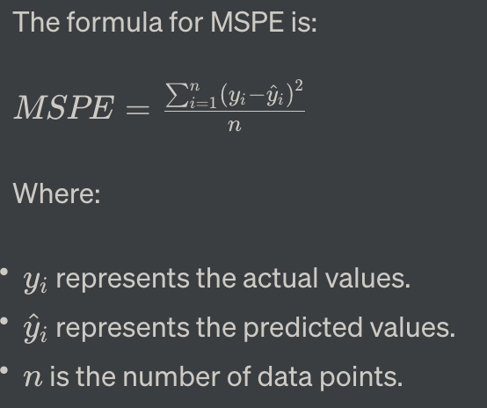

›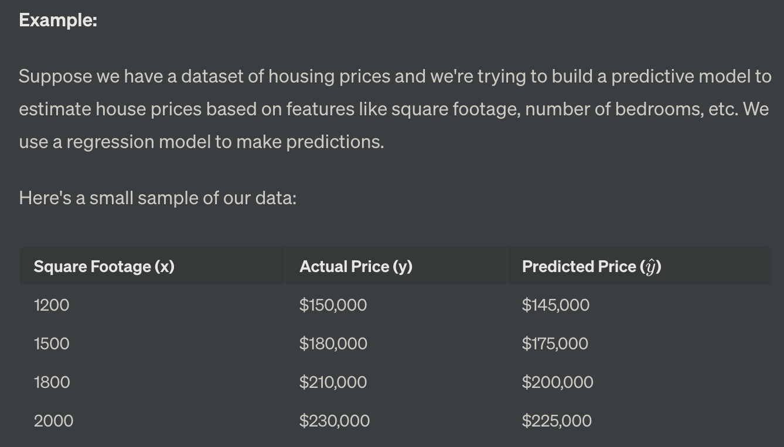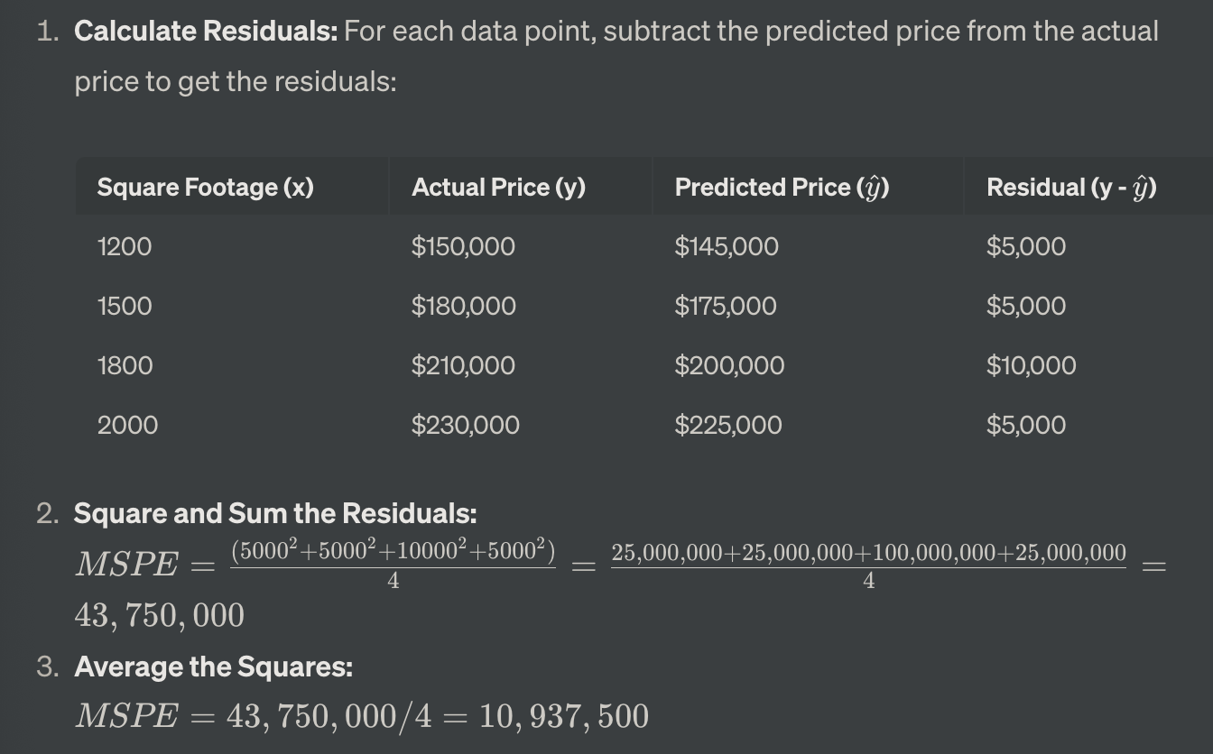

expected mean-squared prediction error

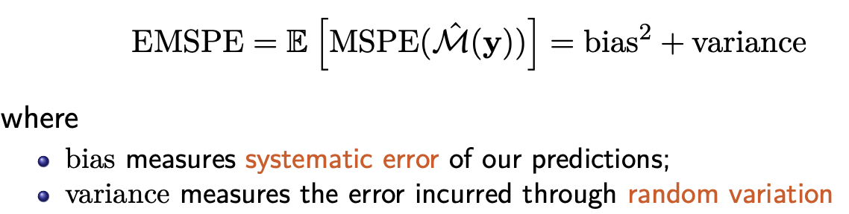

## Variance and Bias with EMSPE

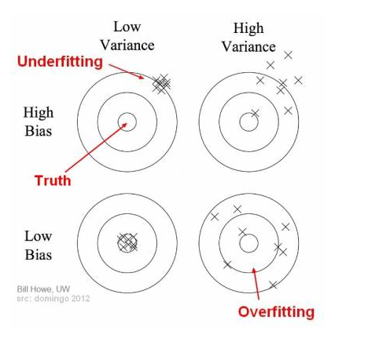

Regardless of how much training data from the population we see, we cannot make a quadratic look like a fifth order polynomial.

* The increase in EMSPE introduced by underfitting is therefore primarily due to It has high bias and low variance
* The increase in EMSPE introduced by overfitting is therefore primarily due to It has low bias but high variance.

Error/EMSPE = bias + variance

Error反映的是整个模型的准确度，Bias反映的是模型在样本上的输出与真实值之间的误差，即模型本身的精准度，Variance反映的是模型每一次输出结果与模型输出期望之间的误差，即模型的稳定性。

举一个例子，一次打靶实验，目标是为了打到10环，但是实际上只打到了7环，那么这里面的Error就是3。具体分析打到7环的原因，可能有两方面：一是瞄准出了问题，比如实际上射击瞄准的是9环而不是10环；二是枪本身的稳定性有问题，虽然瞄准的是9环，但是只打到了7环。那么在上面一次射击实验中，Bias就是1,反应的是模型期望与真实目标的差距，而在这次试验中，由于Variance所带来的误差就是2，即虽然瞄准的是9环，但由于本身模型缺乏稳定性，造成了实际结果与模型期望之间的差距。

* **Bias** refers to the error introduced by approximating a real-world problem, which may be extremely complex, by a much simpler model. High bias can cause a model to miss relevant relations between features and target outputs (underfitting).
* **Variance** refers to the error introduced by the model due to its complexity. A model with high variance is sensitive to small fluctuations in the training data, capturing noise along with the underlying patterns (overfitting).

Balancing bias and variance is a fundamental

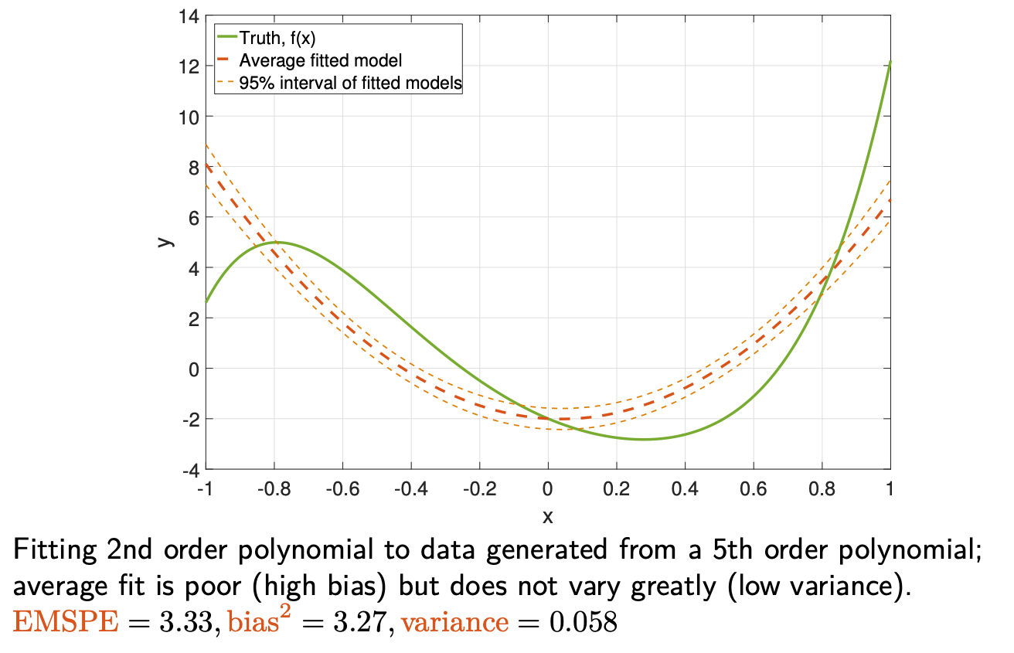

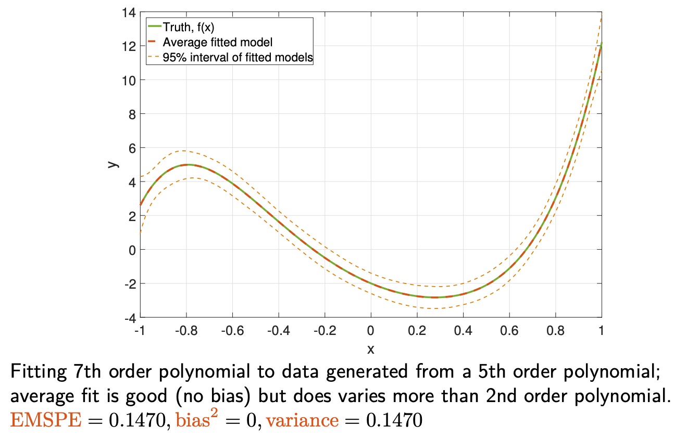 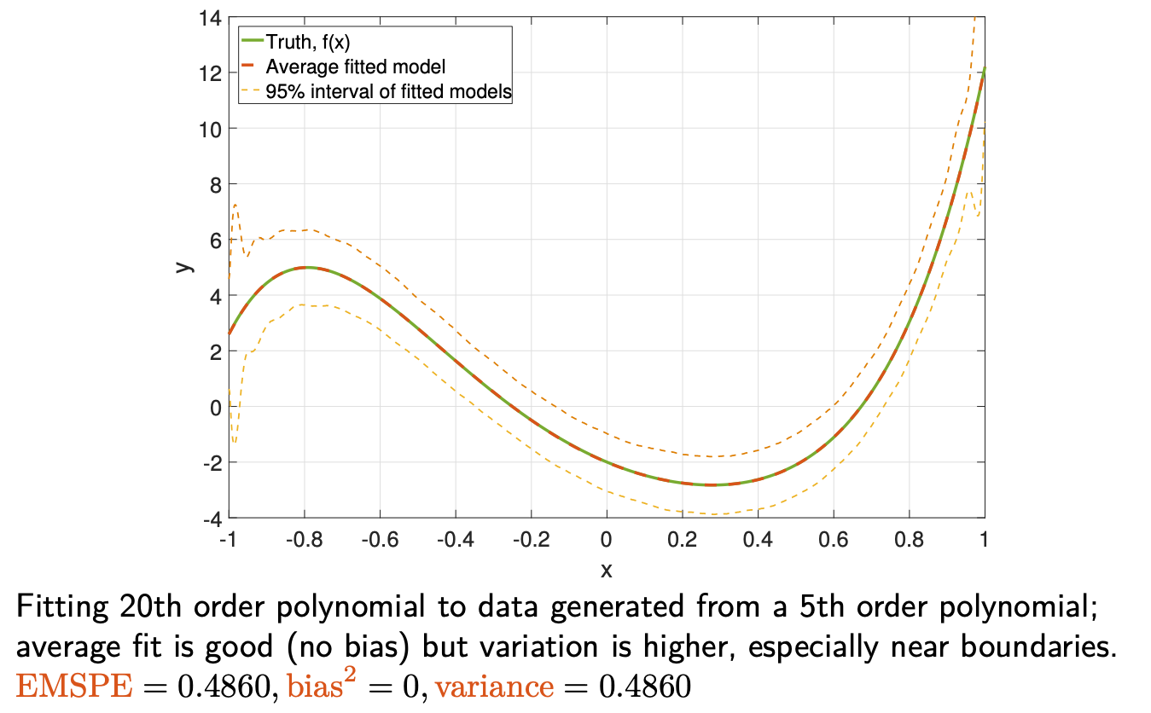

## Selecting Predictors

### Hypothesis testing and Multiple Testing Problem

### Likelihood and Information Criteria

信息准则（Information Criterion）是一种统计度量，用于在给定一组数据时选择最合适的模型。它结合了模型对数据的拟合优度和模型的复杂度，帮助找到一个在解释数据和避免过度拟合之间取得平衡的模型。

在比较模型时，较低的信息准则值表示模型拟合效果更好。它用于相对比较模型的优劣，而不是提供绝对的拟合质量度量。

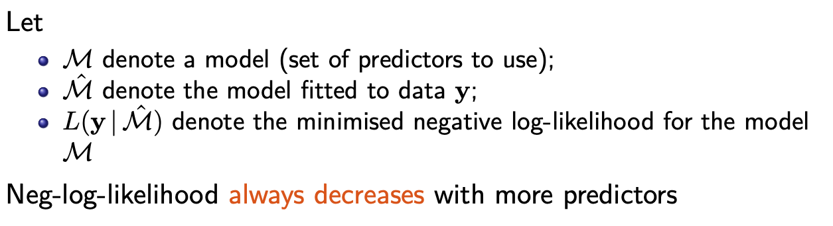 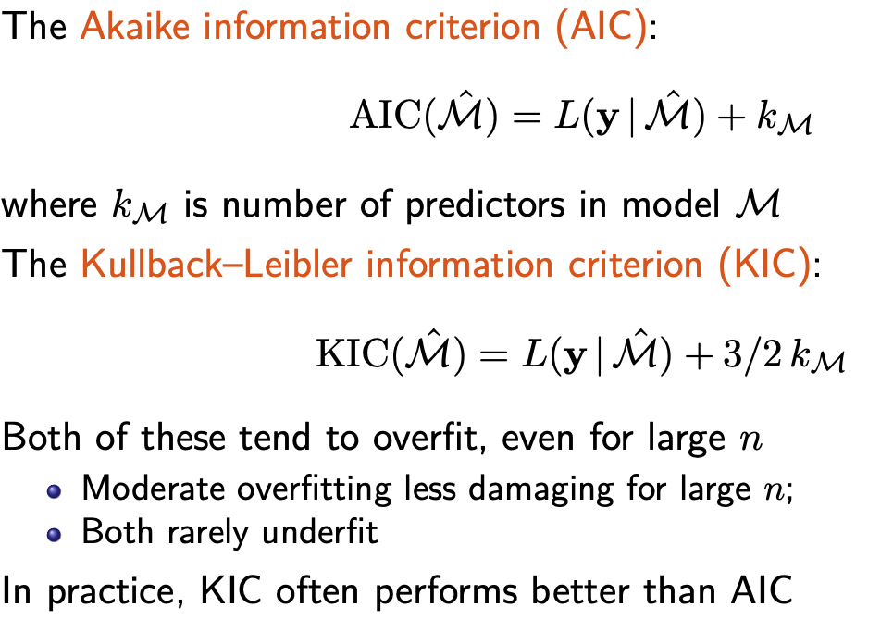 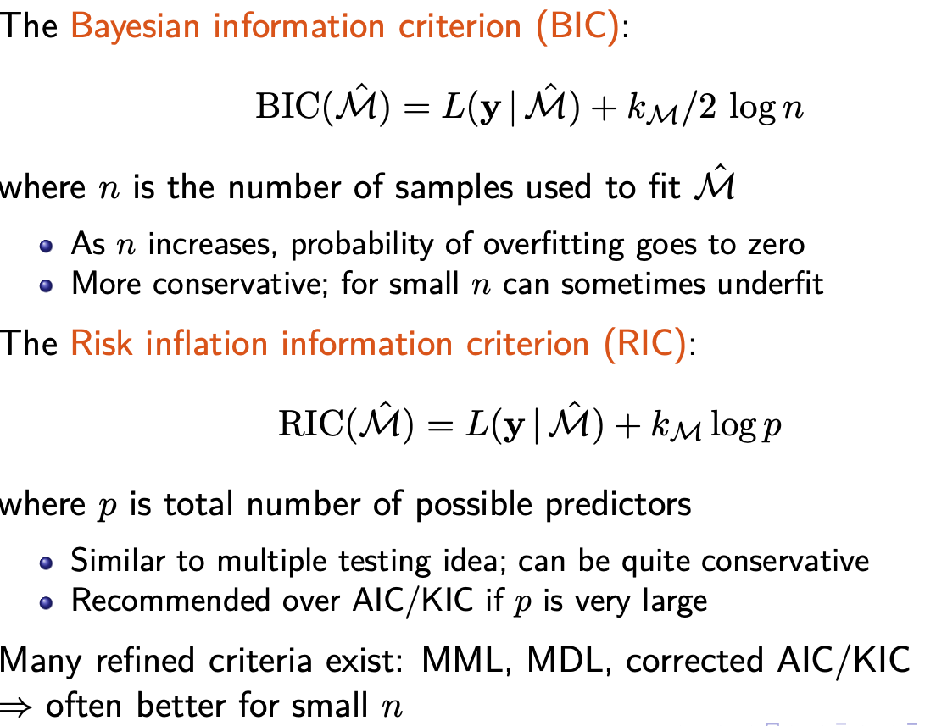

### Cross-Validation

交叉验证（Cross-validation）是一种用于评估机器学习模型性能的统计方法。它通过将数据集分成多个子集，然后在训练和测试阶段中多次使用这些子集来评估模型的性能

1. **步骤：**
   * 将数据集分成 *k* 个子集，其中 *k* 通常是一个较小的整数，比如 5 或 10。
   * 对于每个子集，将其作为测试集，其余的子集作为训练集。
   * 在每次迭代中，用训练集来拟合模型，然后使用测试集来评估模型的性能。
   * 重复这个过程 *k* 次，确保每个子集都被用作测试集至少一次。
2. **目的：**
   * 通过在不同的子集上测试模型，可以获得对模型性能的更稳健评估，而不会过分依赖于单一的数据分割。
   * 交叉验证可以帮助检测模型是否过拟合或者欠拟合。如果模型在不同的子集上都表现良好，那么它可能对新数据也能很好地泛化。

假设我们有一个包含1000个样本的数据集，我们决定使用5折交叉验证来评估一个线性回归模型。

1. 将数据集分成5个子集，每个子集包含200个样本。
2. 第一次迭代：
   * 将第一个子集作为测试集，剩下的四个子集作为训练集。
   * 使用训练集来训练线性回归模型，然后在测试集上评估性能。
3. 第二次迭代：
   * 将第二个子集作为测试集，剩下的四个子集作为训练集。
   * 重复训练和评估的过程。
4. 依此类推，直到每个子集都充当过一次测试集。
5. 最后，将每次迭代的性能评估指标（比如均方误差）取平均值，作为模型性能的综合评估。

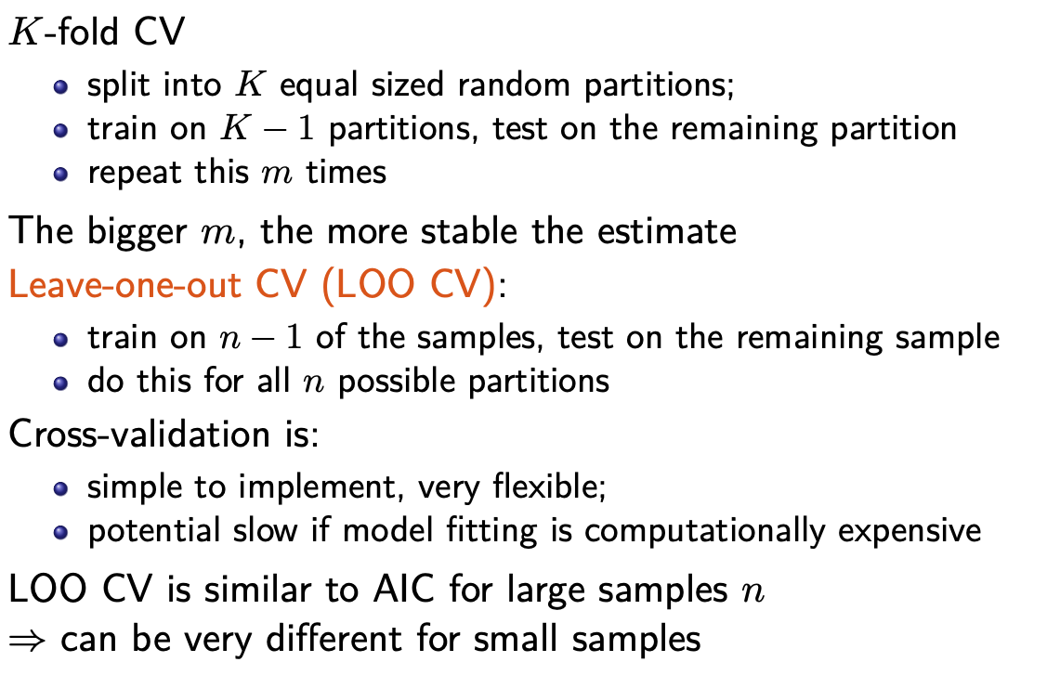

## Penalized Regression

### Conventional Model Selection Methods

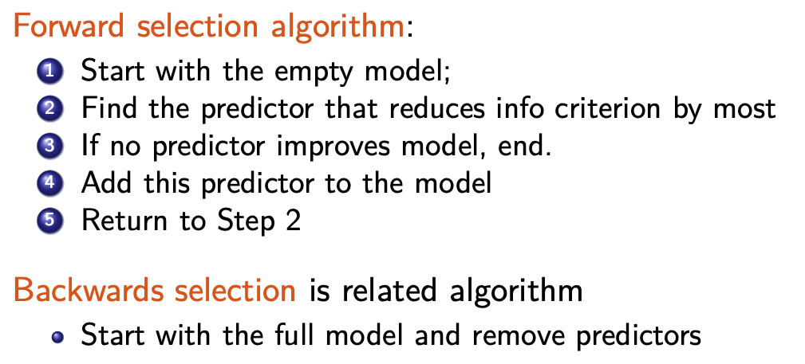

##### Problems with traditional methods

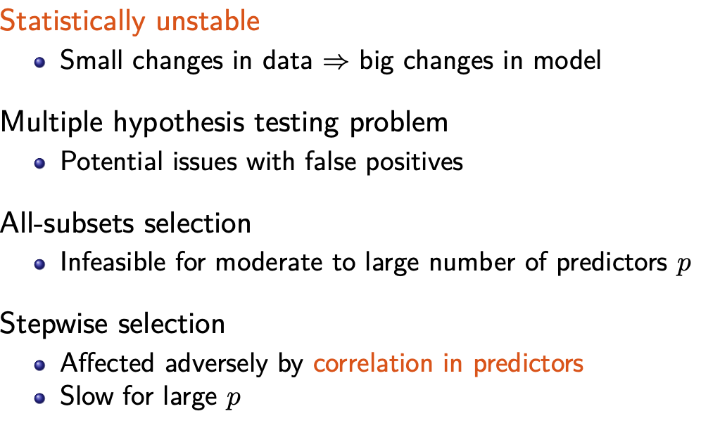

### Statistical Instability

**统计不稳定性**（Statistical Instability）是指在统计模型或方法中，结果对于数据的微小变化或不同的抽样可能会产生显著的变化或波动。

假设我们正在研究房屋价格与房屋大小之间的关系。如果我们在不同的子集中进行数据分割，并在每个子集上拟合模型，如果模型参数（如斜率和截距）在不同子集上发生显著变化，这表明模型可能具有统计不稳定性。

### Penalized Regression

是一种在线性回归等模型中引入惩罚项以控制模型复杂度的方法。这些惩罚项会在模型拟合过程中对系数进行惩罚，以减少模型对训练数据的过拟合。

在线性回归中，我们有惩罚最小二乘法，它要求找到能最小化带惩罚的残差平方和的系数估计：

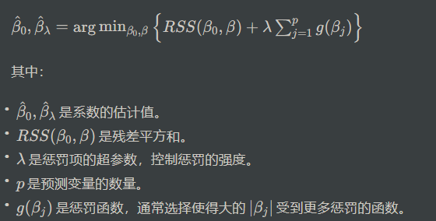 

相比之下，我们在第六讲中学到的普通最小二乘法只考虑了拟合的好坏（残差平方和），而不考虑系数的值。

我们选择这种形式的惩罚的原因是因为较大的系数意味着强烈的影响，即如果一个系数很大，那么目标变量的期望值随着预测变量的单位变化而变化也会很大。另一方面，系数为零意味着预测变量与目标变量之间没有关联。因此，我们的惩罚应该鼓励系数的较小值，以减少过度拟合。

# Week 9 Trees and Nearest Neighbour Methods

## Machine Learning

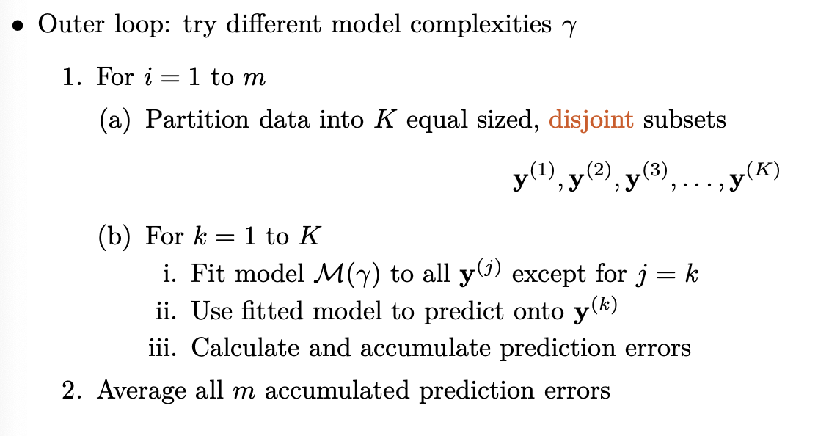

## Decision Trees

A Decision Tree is a supervised machine learning algorithm used for both classification and regression tasks. It works by recursively partitioning the data into smaller and smaller subsets based on features, eventually arriving at a decision or prediction.

Root is the topmost node of the tree. Edge is the link between two nodes. Child is a node that has a parent node. Parent is a node that has an edge to a child node. Leaf is a node that does not have a child node in the tree.

### classification vs regression

#### classification

Classification aims to categorize data points into predefined classes or categories.

The output of a classification model is a class label or category (e.g., "spam" or "not spam," "cat," "dog," or "bird").

#### Regression

Regression aims to predict a continuous numeric value or quantity.

The output of a regression model is a real number or a range of values.

## Random Forests

---

## Nearest Neighbour Methods

### k-means algorithm (K MEAN)

Based on Clustering: grouping data based on similarity patterns based on distance

The k-means algorithm tries to find the k centroids of k clusters of data. It works as follows: (a) Randomly initialise the k centroids (b) Find which data points are closest to which of the k centroids (form clusters) (c) Re-estimate the location of the cluster centroids using the data closest to that centroid (d) Repeat from Step (b) until convergence.

### k means vs knn

this is knn,

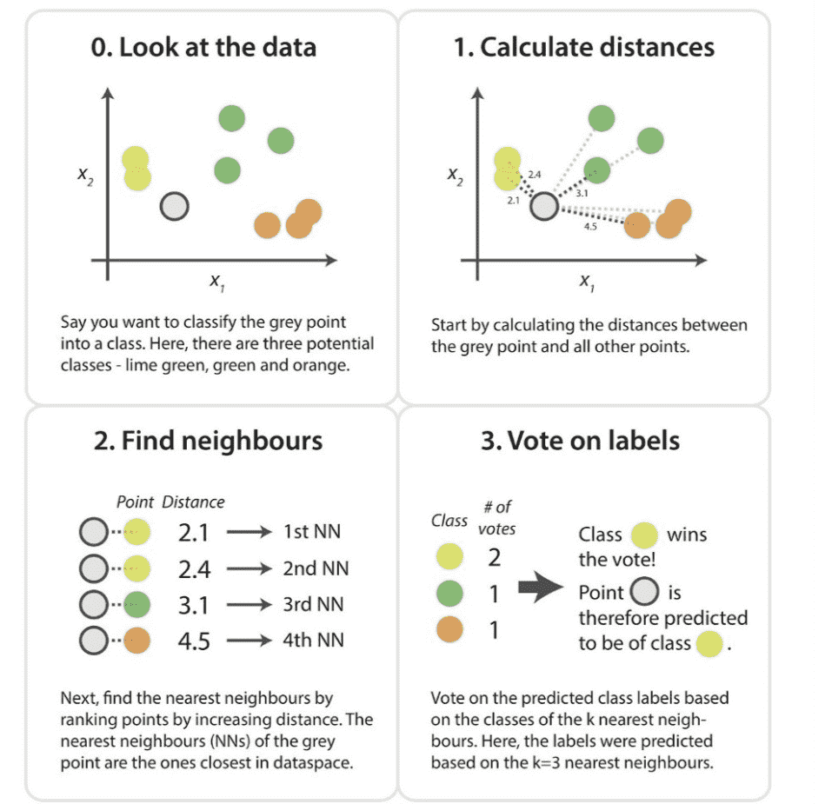

and knn is supervised learning but k means is unsupervised.

The way to read following:  
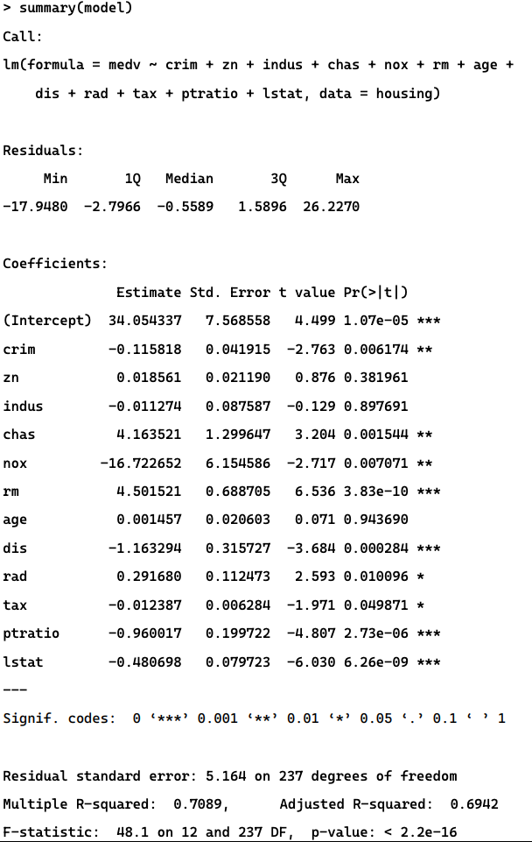

1. **Call**:
   * This line shows the call that was used to create the linear regression model. It specifies the formula used for the regression and the dataset it was applied to.
2. **Residuals**:
   * This section provides a summary of the differences between the observed values (actual data) and the predicted values from the regression model. It includes statistics such as minimum (Min), first quartile (1Q), median (Median), third quartile (3Q), and maximum (Max) values of the residuals.
3. **Coefficients**:
   * This section provides information about the coefficients of the independent variables in the regression model. Each row represents a different independent variable, and it includes:
     + **Estimate**: This is the estimated value of the coefficient. For example, the estimated coefficient for **crim** is approximately -0.115818.
     + **Std. Error**:   
       The standard error is a measure of the precision with the estimated coefficients in a regression model. It indicates how much the estimated coefficients are likely to vary from the true population values if the same model were applied to different samples.
       1. **Lower Standard Error**: A lower standard error indicates that the estimated coefficient is more precise and reliable. In other words, it suggests that the sample estimate is closer to the true population value.
       2. **Higher Standard Error**: A higher standard error indicates that the estimated coefficient is less precise and more uncertain. It suggests that the sample estimate may vary more from the true population value if the model were applied to different samples.
     + **t value**: This is the t-statistic for testing if the estimated coefficient is significantly different from zero.
       1. 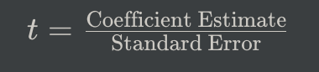
       2. **Higher t-value**: the estimated coefficient is more likely to be statistically significant. This means there is stronger evidence that the independent variable has an impact on the dependent variable.
       3. **Lower t-value**: the estimated coefficient is less likely to be statistically significant. This suggests that the independent variable may not be providing meaningful information for predicting the dependent variable.
     + **Pr(>|t|)**: It indicates the probability of observing a t-statistic as extreme as the one computed, assuming the null hypothesis (the coefficient is zero) is true. In this context, lower p-values suggest more significant coefficients.
       1. **原假设 （H0）：**对应自变量的系数为零，表明该变量对因变量没有影响。
       2. **备择假设 （H1）：**对应自变量的系数不为零，表明该变量对因变量有影响。
       3. 因此，如果系数的 p 值非常小（通常小于所选显著性水平，如 0.05），则表明存在反对原假设的有力证据。

1. **Signif. codes**:
   * These codes (e.g., ***, **, *) are used to indicate the level of significance of each coefficient. The more asterisks, the more statistically significant the coefficient is. For example, "***" indicates very high significance, while "." indicates low significance.
2. **Residual standard error**:
   * This is an estimate of the standard deviation of the error term (residuals). It measures the average deviation of the observed values from the predicted values.
3. **Degrees of freedom**:
   * This indicates the degrees of freedom associated with the residuals and the model. In this case, there are 237 degrees of freedom for the residuals.
4. **Multiple R-squared**:
   * This is a measure of how well the independent variables explain the variation in the dependent variable. It ranges from 0 to 1, with 1 indicating a perfect fit.
5. **Adjusted R-squared**:
   * This is the R-squared value adjusted for the number of predictors in the model. It penalizes the R-squared value for including unnecessary variables.
6. **F-statistic**:
   * This is the value of the F-statistic, which is a measure of overall significance of the model. It tests the null hypothesis that all of the regression coefficients are zero.
7. **p-value**:
   * This is the probability associated with the F-statistic. It indicates the likelihood of observing an F-statistic as extreme as the one computed, assuming the null hypothesis (all coefficients are zero) is true. In this case, the p-value is very close to zero, suggesting that at least one of the independent variables is useful in predicting the dependent variable.